GAZA LAYS BARE OUR INTERNATIONAL LEGAL DISORDER
Can Developing Countries Lead the Way to a More Just World?

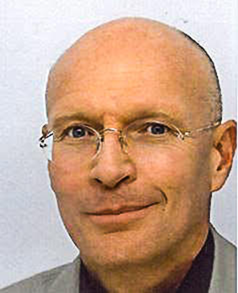
Dr. William Paton, a Canadian, is a former UN official at the Assistant-Secretary General level. He served as the top UN official, ‘Resident and Humanitarian Coordinator’, in Congo, Tajikistan and Somalia; as Director of the UN's Pandemic Influenza Contingency based in Geneva; Director of Country Programs globally at the Global Fund to Fight AIDS, TB and Malaria in Geneva; and Deputy Director General/Special Envoy of the International Development Law Organization based in Rome. He has also worked for the Chinese Academy of Science in Beijing. www.billpaton.com

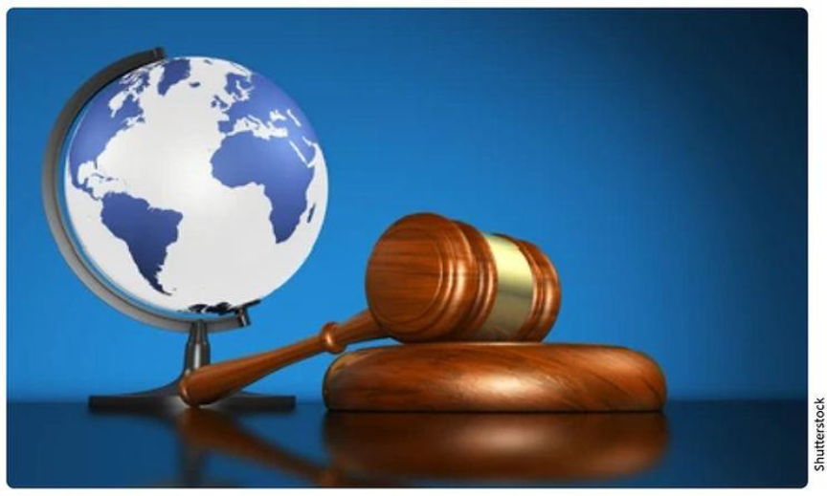
by William Paton, Beijing
21 April 2024

The cruel war in Gaza, risking the sparking of a larger war in the Middle East, lays bare, once again, the frightful arbitrariness of international justice. International rule of law has always been about rule by great powers, and far less about impartial application of our world's laws, laws which have been suspended for Israel. The USA, in particular, refuses to abide by many key laws, even ones almost all other countries accept, picking and choosing as it likes. It is clearer than ever, if we want a more just and more peaceful world, developing nations -- the Global Majority -- must stand up and demand one law for all.

Making up the rules
Perry Anderson writes that international law has always been subservient to the dominant powers. While there had for thousands of years been some inkling of 'laws of war', nothing was codified. Until, that is, an inspired Dutchman, Hugo Grotius, wrote his 1625 treatise, The Law of War and Peace, (1) beginning a new great power game of making up laws to suit themselves, and ignoring them whenever they liked.
Adam Smith and Emmanuel Kant condemned colonialism in the latter part of the 1700s, putting its morality, and its legality, on the world agenda. After centuries, the slaving nations of Europe and the United States made trade in humans illegal, beginning with Denmark in 1803, followed by the UK and USA and then all major European powers by the 1830s. They finally ended the trans-atlantic slave trade in the 1860s, by which time most slaves were freed.
At that point, things seemed off to a good start; Europe was slowly stitching together a patchwork of national and international law. It was, however, often unjust; for instance, the 1814-15 Congress of Vienna accorded extraordinary powers to the UK, Russia, Austria, Prussia and France, compared to other states. In 1883, a prescient Scot, James Lorimer, seized on this as proof states were not, in fact, equal. (1)
European powers saw emerging international law as purely their own invention. Yet Mencius, a Confucian philosopher, condemned hegemony in the fourth century BCE, arguing then already that inter-state relations should be guided by moral principles. Though he accepted there was a hierarchy among states, he believed conflicting interests among rulers should be reconciled peacefully, over time. Mencius saw war for land or people as immoral and proposed that rulers have a duty to intervene in the affairs of other states to promote peace and righteousness. (2) Over two millennia later, this same principle was adopted in the United Nations Summit Outcome Document in 2005, as the Responsibility to Protect or 'R2P.' Never mind, either, Indian thinkers, another state whose culture was already rich in philosophy about justice and rule. Europe then plunged into a series of devastating wars and the United States emerged as the world's new, self-appointed, 'General Counsel.'
In 1920, the victorious allies of World War I created the League of Nations, the first world organisation dedicated to keeping the peace. The United States never joined. Japan, Germany and Italy quit in the 1930s. The Soviet Union only joined in 1935 and was expelled in 1939 for invading Finland.
Europe fell back into World War II, including the Holocaust that spurred establishment of the state of Israel in part of Palestine. The victorious allies created a new organization, again aimed at preventing future wars, the United Nations. But in 1945, in Los Angeles, the United States, Britain, France, the USSR and China made it clear they must have a veto over all important decisions.
That day is often heralded as an inspirational moment, when nations came together for saner global governance. But by once again acknowledging that five states would be 'more equal than others,' they may well have doomed us to yet another world war. Any one of those five states can still today, 78 years later, veto the will of all the other 192. (To their credit, France and UK have both refrained since 1989, at the end of the Cold War.) The veto is what leaves the UN's Security Council unable to intervene in so many of the armed conflicts around the world, some of which, like the war in Gaza, have the potential to mutate into World War III and consume us all.
It can be argued the other 46 founding states who signed in Los Angeles that day should not have caved in so easily, and have held out for a better deal. However, as Hugo wrote, the great powers would not have accepted so fair an international justice system. International rule of law was to be just another instrument of their power over others, backed as always by the threat of violence, if in a slightly less arbitrary fashion. Indeed, the United States and allies such as the UK, prefer not to talk of international rule of law at all, choosing instead to speak of 'upholding a rules-based international order,' an order they continue to dominate.

Ignoring the Laws
Since World War II, many new international laws were set up under USA leadership, even though the USA often refused to accept that those laws apply equally to themselves. For instance, they have refused to join, ratify and abide by, the:
- doomed League of Nations,
- Convention on the Rights of the Child (193 parties),
- Convention on the Elimination of All Forms of Discrimination Against Women (187 parties),
- International Criminal Court (121, though neither China nor Russia have joined either),
- UN Convention on the Law of the Sea (161 parties),
- Comprehensive Nuclear-Test-Ban Treaty (157 parties),
- The Kyoto Protocol (on reducing greenhouse gas emissions in developed countries (160 parties),
- Paris Agreement on climate change (195 signatories), (the USA joined, quit, and rejoined but may quit again soon),
- Ottawa Convention on landmines (164 parties),
- Convention on Biological Diversity (196 parties; the USA is the only UN member state that has not ratified it).

The USA also clings to its sole veto power in the:
- World Bank, and
- International Monetary Fund, both headquartered in Washington, insisting that even if all the other 189 member states agree on something, it can veto it alone.

The USA has also now withdrawn from other legal agreements including the:
- Intermediate-range Nuclear Forces Treaty (along with placing nuclear launchers in Romania),
- World Trade Organization, (de facto, by blocking approval of judges, leaving the WTO unable to hear new cases),
- and will possibly also withdraw from the Strategic Arms Limitation Treaty (SALT 2) which Trump has promised to do if re-elected, eliminating limits on nuclear weapons.
- signed trade agreements, too, are routinely torn up.

Nonetheless, there have also sometimes been glimmers of light -- encouraging moments such as the Geneva Convention on war, in 1949; or 1967, when the USA, Russia and United Kingdom were first to sign the UN Outer Space Treaty, banning nuclear weapons in space or militarization of the moon; or the original signing of the Paris Agreement in 2015, based on an innovative new approach.

The Laws of War
International Humanitarian Law is grounded in the Geneva Conventions of 1949, together with other treaties and customary international law. It applies to both states and non-state armed groups, no matter what the other side has done, and also governs conflict during illegal occupation of a territory.
The fundamental rule of international humanitarian law in conflict is that all parties must distinguish between combatants and civilians, and civilians and civilian objects must never be targeted. It is not enough to claim civilians are not the target; the law requires parties to the conflict to take all feasible precautions to minimise harm to civilians and civilian objects. If an attack will likely cause disproportionate harm to civilians, it is prohibited. Taking hostages is prohibited and prisoners of war must be treated humanely. Attackers must warn civilians of impending danger and take all feasible measures to protect them, even those who do not evacuate. Statements that are not genuine warnings, but are intended to threaten violence to force people to leave, are prohibited.

War Crime in Gaza Lays Bare Our International Legal Disorder
For decades now, Israel has illegally occupied the Gaza Strip, rendering it a criminally apartheid, open-air prison. Palestine has been accepted by the UN as a non-member observer state, making Israel undeniably the illegal occupier of another state.
War crimes committed in Gaza since the Hamas attacks in Israel, 7 October, include deliberately attacking civilians. They have not only bombed houses indiscriminately; they have put in place a scheme to wait to target people once they have returned to their homes, so as to kill their spouses and children too (the software is called 'Where's Daddy' and has been widely reported on in Israel). Most homes and buildings in a territory of 2.4 million people have been destroyed or badly damaged, including most hospitals and schools, again deliberately. Over 13,000 children have been killed. Deliberately.
Israel is also committing the war crime of collectively punishing Gaza’s entire population, cutting off food, water, electricity and fuel, and displacing almost the entire population. It is also committing the war crime of wilfully blocking humanitarian relief, causing large-scale famine in which children, especially, are now literally starving to death. The list of crimes is much longer, including massacres, forced evacuation and torture. For instance, one Israeli doctor at a field hospital in Gaza went public: 'Two prisoners had their legs amputated due to handcuff injuries,' he said, describing deplorable conditions and violations of medical ethics and the law in a letter to Israel's Attorney General. (4) Human Rights Watch says they have confirmed video footage of Israel using white phosphorous over civilian neighborhoods in Gaza and Lebanon, a chemical which burns to the bone, another war crime. (5)
Yes, Hamas started this round of fighting, and has also committed war crimes, targeting civilians, taking hostages, most likely including rape and torture, and using civilians as shields. But the Law of War is clear: Nothing the other side has done justifies war crimes.
American Culpability
As evidence of war crimes in Gaza and Lebanon is overwhelming, the parties should be held accountable. The International Criminal Court (ICC) in The Hague has jurisdiction over war crimes and other serious international crimes committed in Palestine.
By continuing to arm and provide political protection to Israel, the United States is, once again, brazenly flaunting application of international rule of law. The US has used its veto 42 times to block Security Council resolutions condemning Israel's persecution of Palestinians.
The majority of arms being used in Gaza by Israel are American: The Washington Post revealed in late March 2024, that Washington's current arms packages for Israel includes more than 1,800 MK84 2,000-pound bombs and 500 MK82 500-pound bombs. Such 2,000-pound bombs have already caused illegal, mass-civilian deaths in Gaza and more are being delivered to Israel right now. Altogether, the USA has made more than 100 sales and deliveries of arms to Israel since the war's start, 7 October, dividing the arms into smaller sales in order to stay under a threshold and thus avoid Congressional scrutiny. The USA is also breaking its own laws, rather absurdly, by pretending to find 'no violations of humanitarian law in Gaza by Israel,' which if admitted would oblige suspension of arms sales to them. The White House tries hard to spin it, spouting rhetoric about Israeli 'excesses' to mollify Palestine's defenders, while leaving no doubt whose side they're on.
What action has been taken by other 'upholders' of the 'rules-based international order?' Well, Canada, the Netherlands, Japan, Spain and Belgium have all suspended arms sales to Israel, but none are a significant source. Before the war already, eight EU members had recognised Palestine as a state, (3) and now Ireland, Spain, Slovenia and Malta are discussing joining them. But apart from the USA, other key Western powers including the UK and Germany also continue to support Israel strongly, at present providing them with significant amounts of new arms to use in Gaza.

The New Champions of International Justice?
Today's new champions of rule of law in Palestine are over 60 countries of the Global South who are supporting the case against Israel in the International Criminal Court, brought first by South Africa (who know apartheid well), under the 1948 Genocide Convention. South Africa has been joined by Bolivia, Brazil, Columbia, Comoros, Jordan, Malaysia, the Maldives, Nicaragua, Pakistan, Turkey, the Arab League and the Organization of Islamic Cooperation, altogether 63 countries. Not one Western country has supported the case, with the USA, UK and Germany explicitly rejecting it and the European Union declining to comment. China, too, has remained mostly silent, though it condemns Israel's conduct in Gaza. Israel, millions of whose people were exterminated in humanity's worst genocide, is now likely to be found guilty of committing a genocide itself. However, any attempt at enforcement of that ruling will no doubt be vetoed by the United States.
This is the most important international criminal case to be tried in recent history and South Africa may very well have shown the world the way forward out of our current international impasse. No country in the world can afford to be passive any longer about the even-handed application of international rule of law. As the likelihood of a much larger war in the Middle East grows, the time has come for the world's majority to begin to exercise their power, to say: 'We no longer accept that any single nation can veto the collective will of most of the world. We no longer accept that there is not one law for all.' The Global Majority, united, have the strength to raise such an outcry against the trampling of international justice, unleashing such a devastating international backlash in support of simple fairness, that even a super-power will no longer dare to flout the law.

________________________________
1) ANDERSON，Perry (January 2024), Le droit international du plus fort; de Grotius aux Nations Unies, aux Origines de « Deux Poids, Deux Mesures », in Le Monde Diplomatique.
2) 吴根友（18 April 2011), 王道天下观”的历意蕴与与现今国际关系，凤凰网文化综合, （The historical connotation of "The King's View of the World" and current international relations, Phoenix Net Cultural Synthesis), online version accessed 13 April 2024 at:
https://culture.ifeng.com/huodong/special/wangdaoluntan/shendu/detail_2011_04/18/5813597_1.shtml.
Alternatively, KIM, Songmoon (Spring 2010), Mencius on International Relations and the Morality of War: From the Perspective of Confucian "Moralpolitik," in History of Political Thought, Vol. 31, No. 1, pp. 33-56 (24 pages).
3) Poland, Bulgaria, Romania, Hungary, Czechia, Slovakia, Sweden and Cyprus.
4) Haaretz | Israel News (4 April 2024), "Doctor at Israeli Field Hospital for Detained Gazans: 'We Are All Complicit in Breaking the Law,'" by Hagar Shezaf and Michael Hauser Tov.
5) Human Rights Watch website, accessed 14 April 2024, referring to events of 10-11 October 2023, https://www.hrw.org/news/2023/10/12/israel-white-phosphorus-used-gaza-lebanon.

