Report

On

the Asian Scholars` Dialogue with Senior Officials of
The United Nations and International Organizations in Geneva
Monday and Tuesday, 6-7 July 2026
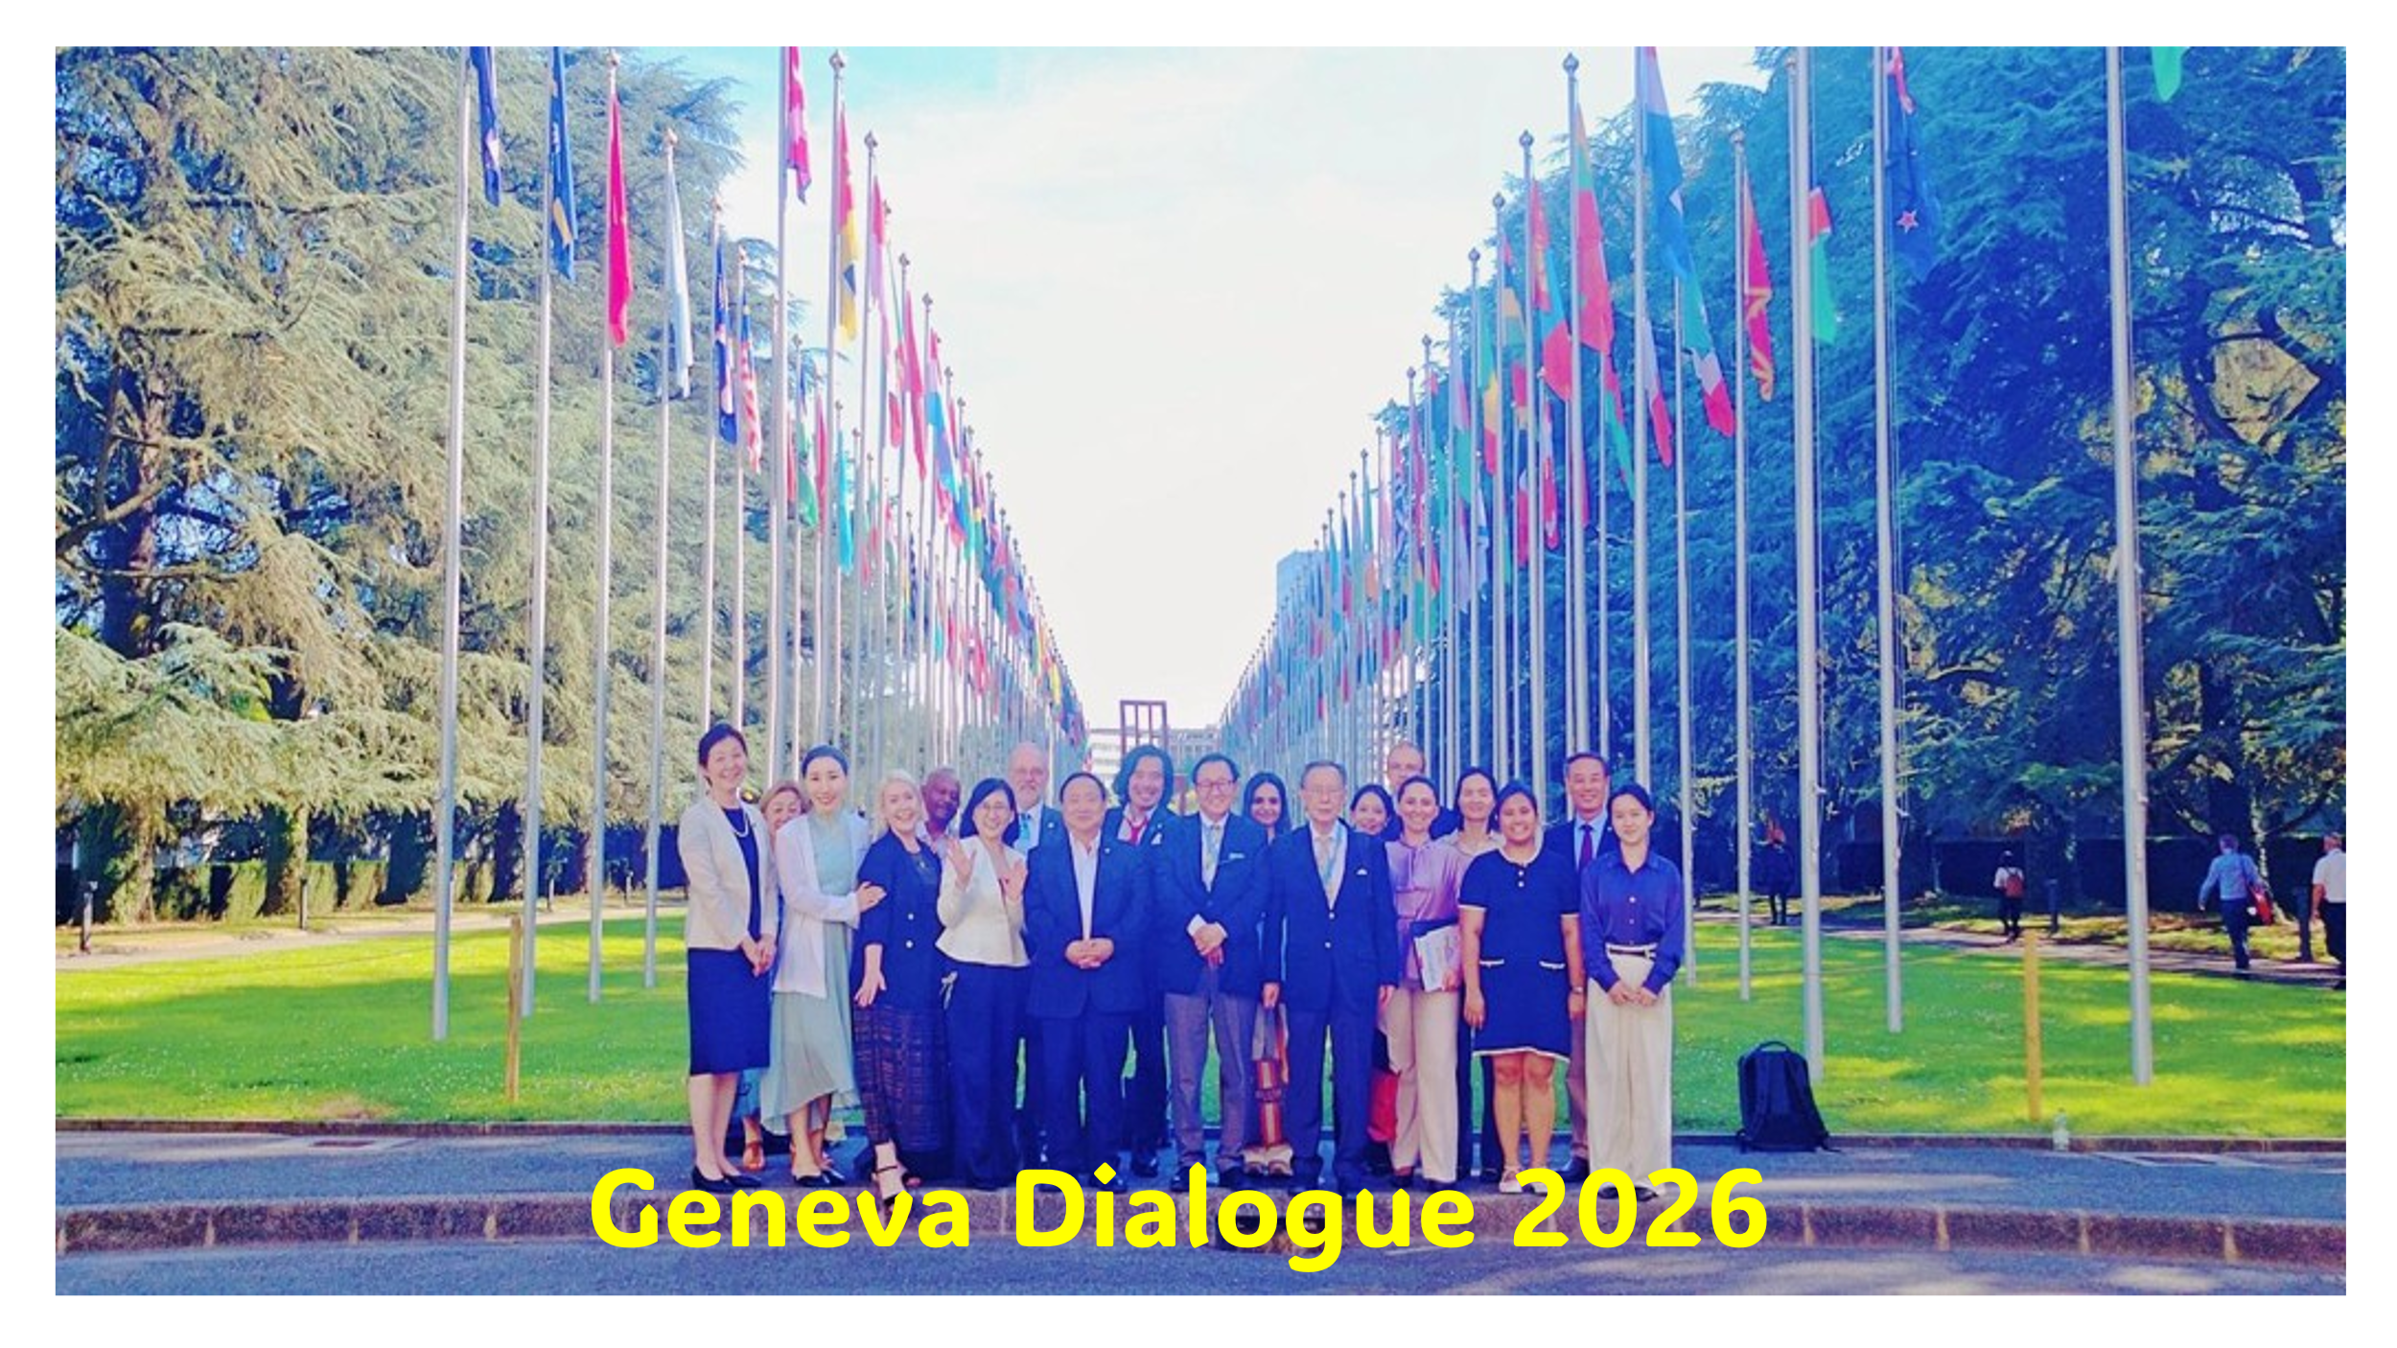

Written by Lauren S. Power

July 2026

Table of Contents

Acknowledgements 3

Session 1: Introductory Meeting
Introductory remarks by Ms. Lidiya Grigoreva, Chef de Cabinet, UNOG 4

Session 2: An Overview of the Critical Issues faced by the UN System
Inspector Conrod Hunte, Chair of the Joint Inspection Unit (JIU) 6

Session 3: Panel Discussion on the UN and Humanitarian Operations
Mr. Michael Emery, Director of Human Resources Management, IOM 12

Session 4: ITU’s Overview, Mission, and Impact of ITU Work
Presentation by Mr. Emmet Ryan, the ITU Study Group Adviser 20

Session 5: World Trade Center and the International Trade Situation
5.1: Briefing by WTO Deputy Director-General Zhang Xiangchen 27
5.2: Meeting with WTO Director-General Ngozi Okonjo-Iweala 34

Session 6: Office of the High Commissioner for Human Rights
Mr. Rory Mungoven, Chief, the Asia-Pacific Section and

Mr. Marco Zanin, Coordinator, the Global Alliance Initiative 39

Session 7: Concluding Session on the United Nations at a Crossroads
Director-General Tatiana Valovaya, the United Nations Office at Geneva 46

Appendix A: Social Gatherings at the Asian Scholars’ Dialogue

Dinner organized by Dr. David Chikvaidze, Former Chef de Cabinet of
Office of theDirector General on Sunday, 5 July 2026 52

Guided group tour, Monday, July 2026 53

Lunch (Palais des Nations Cafeteria) on Monday, 6 July 2026 54

Reception hosted by the Japanese Permanent Mission, 6 July 2026 55

Acknowledgements

At the conclusion of the Asian Scholars` Dialogue with Senior Officials of The United Nations and International Organizations in Geneva, held on Monday and Tuesday, 6-7 July 2026, on the theme of “Prospect for Recovery of International Cooperation,” we acknowledge the generous contributions of all those who helped make this event possible.

The Dialogue affirmed that the recovery of international cooperation depends not only upon institutional reform, but also upon the relationships that sustain multilateralism in practice. Across the sessions, speakers repeatedly emphasized the importance of continued engagement, open exchange, intellectual humility, and the willingness to listen across national, professional, and political differences. Through the exchanges between UN Leaders and Dialogue Delegates and through the camaraderie developed among participants mutual understanding was strengthened, demonstrating how scholarly dialogue can cultivate trust, friendship, and enduring collaboration. We therefore extend our appreciation to all participants for contributing not only their expertise, but also the spirit of collegiality and shared purpose upon which meaningful international cooperation ultimately depends.

With warmest thanks for their valuable time and meaningful guidance in coordinating and organizing sessions for the Asian Scholars’ Dialogue, we recognize the contributions of:

Convenor and Global Coordinator: Sukehiro Hasegawa

Coordinator in Geneva: Lidiya Grigoreva and David Chikvaidze

Session Organizers and Moderators

Session 1. Lidiya Grigoreva (UNOG)

Session 2. Toshiya Hoshino (JIU)

Session 3. Michael Emery (Humanitarian organizations)

Session 4. Emmet Ryan (ITU)

Session 5. Laura Roig (WTO)

Session 6. Gloria Nwabuogu (UNHCHR)

Session 7. Lidiya Grigoreva (ITU)

We further recognize the participation and contributions of the 2026 Asian Scholars’ Dialogue Delegates, including: Dr. Sukehiro Hasegawa, Ms. Motoko Mizuno, Mr. Masakuni Tanimoto, Ms. Yuriko Shoji, Dr. Zhang Guihong, Dr. Sheng Hongsheng, Dr. Vesselin Popovski, Dr. Ramaswamy Sudarshan, Dr. Sho Akahoshi, Dr. Xinyu Yuan, Ms. Jiang Junji, Ms. Zhao Ruozhen, Dr. Yuna Lee, Ms. Shalvi Ponwar, Dr. Jamie Pring, and Ms. Kahoruko Hoshino.
We give special acknowledgement to the Secretariat members: Dr. Arbenita Sopaj, for her management and communication; Ms. Aki Kawabata, for her photography and videography; and Ms. Lauren S. Power, for drafting this report.

Session 1: Introductory Meeting
The first session of the Asian Scholars’ Dialogue opened at the United Nations Office at Geneva with introductory remarks by Ms. Lidiya Grigoreva, Chef de Cabinet of the Director-General of United Nations Office at Geneva (UNOG). Ms. Grigoreva welcomed the participating scholars and expressed appreciation to the colleagues who had contributed to organizing the Dialogue, including Mr. David Chikvaidze and Professor Sukehiro Hasegawa. She thanked them for their sustained commitment to the initiative and emphasized the importance of continuing the exchange between Asian scholars and officials of the United Nations and other international organizations.
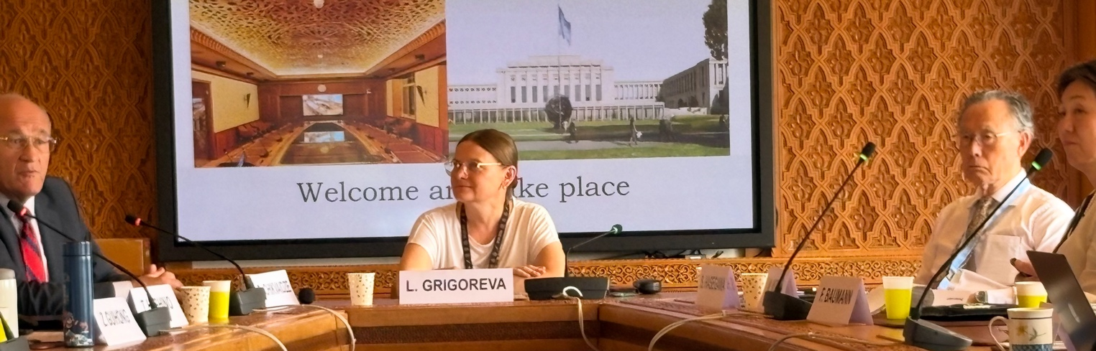
Ms. Grigoreva observed that the 2026 theme of the Dialogue, “Prospect for Recovery of International Cooperation,” was especially timely. The international community was confronting profound uncertainty arising from a rapidly changing geopolitical landscape, shifting political and economic conditions, and declining confidence in multilateral institutions. At a time when many of the most serious challenges were global in character, however, isolation could not provide a viable response. Recalling an observation that, if the United Nations did not exist, it would have to be created, she underlined the continuing necessity of an institution capable of bringing states and other actors together.
She described Geneva as occupying a distinctive place within the United Nations system. As the Organization’s largest duty station outside New York, UN Geneva serves as an important center for human rights, development, humanitarian cooperation, and dialogue on science and technology. It also provides an essential space for building trust in the multilateral system. Trust, inclusivity, cooperation, and partnership, she noted, are created not only through major diplomatic initiatives, but through patience, sustained dialogue, a willingness to cooperate, and the search for common ground. These are among the principal functions that the UN Geneva continues to perform.
Addressing the scholars directly, Ms. Grigoreva emphasized the reciprocal value of engagement between academic and policy communities. Policymaking can be strengthened when it is informed by evidence, research, and critical analysis. At the same time, scholars can ensure that their work remains grounded in institutional and political realities by engaging directly with practitioners and decision-makers. The Asian Scholars’ Dialogue therefore offered more than an exchange of information: it created an opportunity for academic expertise and institutional experience to inform one another.
Ms. Grigoreva further stressed the central importance of Asia to the future of international cooperation. Asia is home to more than half of humanity, and its governments, institutions, scholars, and societies will play an indispensable role as new agreements are negotiated and patterns of economic and social development continue to evolve. Contributions and solutions originating within Asia, as well as cooperation between Asian and non-Asian actors, would be essential to addressing shared global challenges.
Multilateralism, she concluded, should not be regarded as an abstract idea. It is a practical response to challenges that extend beyond national borders and cannot be solved by individual states acting alone. The recovery of international cooperation should therefore not be understood simply as an attempt to restore the arrangements of the past. It should instead involve innovation and the development of new forms of multilateral action that are more inclusive, efficient, responsive, and capable of addressing contemporary realities.

Discussion
Following the remarks by Ms. Lidiya Grigoreva, Chef de Cabinet of the Director-General of United Nations Office at Geneva (UNOG), scholars had the opportunity to ask questions. During the discussion, Professor Zhang Guihong referred to the UN80 Initiative and asked about the implications of its three interconnected workstreams for the future capacity of the United Nations. These comprise efforts to achieve efficiencies and improvements through the revised program budget, a review of how mandates established by Member States are implemented, and possible structural changes and program realignments across the UN system.
In her response, Ms. Grigoreva placed particular emphasis on the substantial reduction in posts proposed under the first workstream, described during the session as approaching 20%, and the wider consequences of asking the UN to operate with significantly fewer personnel and resources. The intervention raised a central concern about the reform process: how the UN could reduce costs, eliminate duplication, and adapt its institutional structures without weakening its substantive expertise, institutional memory, or capacity to fulfil the mandates entrusted to it by Member States.
Dr. David Chikvaidze, Former Chef de Cabinet of UNOG's Director General, was subsequently invited to reflect on the origins and continuing importance of the Asian Scholars’ Dialogue. He recalled that the original Dialogue had been established in 2018 through his cooperation with Professor Hasegawa. He expressed satisfaction that Ms. Grigoreva, as his successor in the Office of the Director-General, had taken on the responsibility of working with Professor Hasegawa to sustain and further develop the initiative. The earlier Dialogue had likewise been conceived as a means of enabling scholars and practitioners to engage in frank discussion with senior officials of the UN and other international organizations.
Dr. Chikvaidze emphasized that the program had acquired even greater importance under present circumstances. Budgetary and staffing reductions had generated a call for the United Nations to “do more with less,” but the changes underway extended beyond administrative efficiency. In his assessment, the UN was entering a new era in which many of the familiar reference points that had guided its work were gradually being switched off. This created uncertainty not only about where the UN was going, but also about where it wished to go and how it intended to navigate a changing international order.
He characterized the present environment as one of “belligerent uncertainty.” The actors driving the transformation of the international system did not necessarily possess a clear understanding of its eventual destination. Under such conditions, the need for leadership, cooperation, inclusivity, and institutional innovation was greater than ever. His remarks, therefore, established the broader intellectual and institutional context for the Dialogue: the discussions over the two days would concern not merely how to preserve existing arrangements, but how the United Nations and its partners could recover, adapt, and exercise meaningful leadership in a period of systemic change.

Session 2: Overview of the Critical Issues faced by the UN System with the Joint Inspection Unit
Ambassador Toshiya Hoshino, a member of the United Nations Joint Inspection Unit, introduced Inspector Conrod Hunte, Chair of the JIU, and emphasized the importance of independent oversight in maintaining the credibility of the United Nations system. The session addressed the critical institutional challenges facing the UN at a time of heightened global demand, declining resources, and significant structural reform.
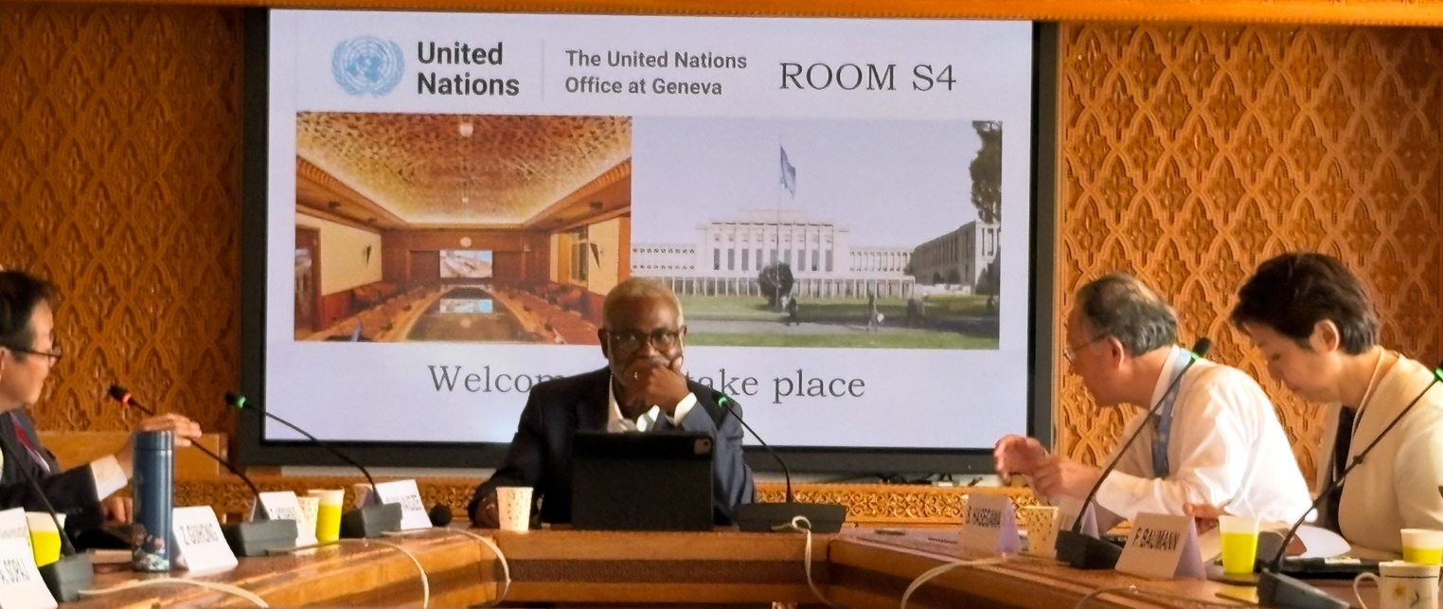
Ambassador Hoshino observed that the JIU contributes to building, defending, and improving the United Nations by strengthening accountability, transparency, and institutional credibility. Global problems can appear overwhelming, but they affect real people and communities. The United Nations must therefore remain a credible and capable partner in addressing them.
Inspector Hunte began by recalling that the UN had been created to confront problems that no individual country could solve alone. The central questions now facing the UN were whether it remained sufficiently strong, intelligent, effective, and adaptive to meet contemporary challenges, and whether it possessed the resources, structures, and institutional capacities required to carry out the responsibilities placed upon it.
These questions had become more urgent as expectations of the United Nations continued to rise while resources became increasingly constrained. Inspector Hunte characterized rising expectations and declining resources as a particularly difficult combination for institutional progress. Although the financial and administrative measures under consideration had emerged from formal review processes and reflected efforts to introduce deliberate change, their practical implications could be severe. At a time of expanding humanitarian need, reduced resources could prevent the UN system from responding adequately.
He cautioned that reform would become dangerous if it were understood primarily as a cost-cutting exercise. Fragmentation could worsen when funding was divided across institutions and accountability remained weak. A persistent gap has been widening between what the UN has been asked to accomplish and what it can realistically deliver with the resources available to it.
Reform, Inspector Hunte argued, could not be limited to a single department or administrative function. It should seek to strengthen institutional discipline, coordination, and performance across the system. At the same time, reductions in expenditure did not automatically generate greater efficiency. Poorly designed cuts could weaken operational capacity, diminish expertise, and make the implementation of mandates more difficult.
He also drew attention to the decentralized character of the UN system. The Secretary-General does not exercise direct authority over all entities, including specialized agencies such as UNESCO. Reforms initiated within the Secretariat would, therefore, not necessarily be adopted uniformly throughout the wider system. Nevertheless, a common approach to reform remained necessary, including systematic examination of the mandates, programs, and working methods of different UN entities.
Inspector Hunte described the JIU as the UN system’s independent external oversight body. Its work is evidence-based and directed toward strengthening governance, accountability, transparency, efficiency, and organizational effectiveness.
Oversight, he stressed, should not be reduced to control or procedural compliance. Its purpose is to ensure that institutions can explain and justify their decisions, demonstrate results, and retain the confidence of Member States and the people they serve. Governance, trust, and credibility are therefore not merely administrative or technical concerns; they are central to the legitimacy of the United Nations.
The JIU’s work extends across a wide range of institutional and policy issues, including human rights, artificial intelligence, staff mental health and well-being, and administrative governance. When organizations are under pressure, decisions should be guided by evidence. Reform processes need to ask how decisions were formulated, what their cumulative effects would be, and how success would be measured and reported. Inspector Hunte emphasized that reform could not rest solely on good intentions or institutional promises. It required reliable evidence, transparent evaluation, and demonstrable change.
The JIU itself is also evolving. Its work has become increasingly concentrated on issues of high-level strategic importance rather than narrower matters of procedural compliance. This shift carried the risk of oversight fatigue, particularly when institutions were expected to monitor and respond to numerous reform processes simultaneously. Nevertheless, independent oversight remained essential to ensuring that reform was efficient, evidence-based, and credible.

Discussion
Professor Sukehiro Hasegawa opened the discussion by asking how the JIU had contributed concretely to enhancing accountability and transparency across the UN system.
Inspector Hunte responded with two examples. First, some UN entities had previously operated without adequate internal oversight arrangements. Through JIU recommendations and sustained advocacy for greater accountability, transparency, and credibility, more entities had established or strengthened their oversight measures. Second, he referred to changes in the process for selecting the United Nations Secretary-General. Whereas the appointment had historically taken place through closed selection by the Security Council, the process had become more transparent and participatory. General Assembly resolution 69-321 was passed in 2015 and brought about provisions for a public list of candidates, vision statements and candidate hearings in the General Assembly, where all countries and civil society participated. This reflected a broader movement toward greater openness and scrutiny within the governance of the United Nations.
Dr. Arbenita Sopaj asked how the JIU was approaching artificial intelligence within the UN system and what position it had adopted regarding the internal use of AI.
Inspector Hunte explained that the JIU was an independent body able to determine its own internal working methods. It was currently reviewing whether and how artificial intelligence should be incorporated into its operations. AI could support efficiency and assist staff with selected functions, and he referred to tools such as Microsoft Copilot, as an example. At the same time, AI raised significant challenges concerning reliability, confidentiality, accountability, and responsible use. The issue therefore remains under review.
Ms. Motoko Mizuno added a comment that AI could potentially be used for recording, transcription, and translation. Such applications might reduce costs and expedite the production of multilingual records.
Dr. Xinyu Yuan posed a two-part question concerning the use of evidence and the coordination of reforms across the UN system. First, she asked how the JIU distinguished technical or factual evidence from evidence influenced by political considerations. Within the UN system, Member-State preferences, donor funding, and political pressure could affect which programs received priority, what information was collected, and how evidence was interpreted. Second, she asked how reform principles could be coordinated across entities with substantially different mandates. Human-rights institutions, for example, operated according to different normative and operational requirements from humanitarian organizations. Common reform measures could therefore be difficult to apply to entities whose purposes and responsibilities were not directly comparable.
Inspector Hunte acknowledged that politicization could occur. He explained that the JIU relied upon a process of “collective judgment” designed to protect the neutrality and integrity of its work. Ten inspectors participated in reviewing the evidence, analysis, and conclusions associated with each inspection or evaluation. Their obligation to exercise independent judgment formed part of the terms of reference governing the review process. This collective approach helped prevent a single political, institutional, or national perspective from determining the outcome.
In response to the second part of the question, Inspector Hunte clarified that the JIU was not an executive decision-making body and did not coordinate or implement reform directly. Its responsibility was to collect and assess information, identify systemic concerns, and issue recommendations. Decisions about implementation remained with governing bodies, executive heads, and the relevant UN entities.
Professor Sheng Hongsheng, drawing on his previous experience in a United Nations peacekeeping operation, observed that the UN had demonstrated both operational effectiveness and considerable administrative waste. He asked whether the JIU had assessed whether the United Nations remained relevant to conduct peacekeeping operations.
Inspector Hunte distinguished between the political relevance of UN peacekeeping and questions of operational or administrative performance. Whether the United Nations should continue to conduct peacekeeping was ultimately a political question for Member States and the relevant intergovernmental bodies. Examples of waste or administrative inefficiency could indicate shortcomings in management, logistics, procurement, or accountability, but did not necessarily establish that the UN lacked a legitimate or continuing role in peacekeeping.
Professor Vesselin Popovski raised the question of public trust and communications. Drawing on his experience teaching students in India, he noted that students frequently asked why they should study an institution that appeared not to work. He recounted his regular response, which was to emphasize that the United Nations was, in many respects, subject to more extensive accountability requirements than most national governments. Nevertheless, negative accounts of the UN attract disproportionate media attention, while its achievements are often poorly communicated. Positive institutional performance did not necessarily generate headlines, public engagement, or online attention. Professor Popovski then asked how the UN could communicate more effectively, present stronger data concerning its achievements, and rebuild public confidence in multilateralism.
Inspector Hunte described the JIU as performing, in part, the role of a guardian of the UN system. It identifies institutional weaknesses while helping organizations preserve their credibility. He agreed that communication and confidence-building were critical but acknowledged that explaining the achievements of a complex and frequently criticized multilateral institution was exceptionally difficult and had no simple solution.
Professor Hasegawa raised a further question concerning external action in response to gang violence and instability in Haiti. He asked how the UN regarded circumstances in which a state or group of states undertook action that the UN, itself, considered it could not perform adequately.
Inspector Hunte responded that states sometimes acted outside established collective mechanisms when they believed that the United Nations was unwilling or unable to respond in the ways they thought best. Such action could raise serious questions under international law and should not be interpreted as necessarily endorsed by the UN. The issue reflected a persistent tension between the limitations of collective decision-making and the willingness of individual states to act independently when multilateral mechanisms were perceived as ineffective.
Ms. Mizuno questioned whether the scale and direction of the reforms under consideration genuinely reflected the will of the world’s peoples. Amidst mounting planetary, humanitarian, and developmental needs, she asked how the UN determined what people actually required or desired. She suggested that direct public consultation or voting might offer a means of measuring global opinion, particularly regarding reform of the Security Council.
Inspector Hunte responded that numerous efforts had been made to reform the Security Council, but that change remained exceptionally difficult. The current arrangements served the interests of certain Member States, and the procedural requirements for reform involved complex negotiations and a very high degree of intergovernmental agreement. Public voting could provide useful information about global sentiment and allow the UN to take the pulse of public opinion. It could not, however, replace the formal decision-making procedures of the United Nations, which were exercised by Member States through voting and, in many contexts, consensus. Even where public consultation produced a clear result, implementation would remain dependent upon established intergovernmental procedures.
Dr. Franz Baumann, drawing on approximately 35 years of service with the United Nations, raised a broader question concerning the organization’s relevance. He asked whether international conditions had changed so fundamentally that unilateral action had become more attractive to states than cooperation. The United Nations, he suggested, did not always help its own position. Institutional initiatives could become burdened by what he characterized as “feel-good measures” and a broader “politics of the impossible.” He asked whether Member States and UN entities were genuinely listening to the JIU and whether a more fundamental review of mandates was necessary to bring the UN into closer alignment with present realities.
Inspector Hunte agreed that these concerns presented serious challenges. Mandate review went far beyond internal coordination or staffing arrangements. It required scrutiny of the substantive responsibilities assigned throughout the UN system. In his view, the JIU’s independent, system-wide status placed it in a strong position to contribute to such a review.
He noted, however, that although the JIU was charged with being an external reviewer to UN reform, including reforms related to the mandate-review process, this role had been questioned from the perspective of cost-cutting. The pushback against JIU in this regard is not without precedent and illustrates the political and institutional constraints surrounding independent oversight.
Inspector Hunte further observed that the UN’s activities were formally grounded in decisions made by its 193 Member States. In practice, however, donor politics could create circumstances in which particular programs or priorities were shaped disproportionately by the preferences of one country or a small number of contributors.
He also cautioned that efforts to reduce redundancy and waste could themselves weaken oversight. When an entity was required to reduce expenditure by approximately 20 per cent, oversight functions might appear to be an obvious target for cuts, even though such functions were essential for determining whether resources were being used appropriately and effectively. Oversight could also become politically contentious. Individuals or institutions subjected to scrutiny might present themselves as victims of the oversight process. These tensions made it particularly important to protect the independence, authority, and resources of the JIU during periods of institutional contraction.
Dr. David Chikvaidze concluded the discussion with a broader historical reflection on the condition of multilateralism. He recalled that the United Nations had been established 80 years earlier as an institutional expression of the broader ideology of multilateral cooperation. Multilateralism extended beyond the UN. The UN was its most visible embodiment, but not its sole expression.
He reflected on the transformation of the international order following the collapse of the Soviet Union and the expansion of United States influence during the subsequent period. In his account, the United States increasingly occupied the political and institutional space created by the end of the bipolar order and became a dominant voice in defining the post-Cold War conception of multilateralism.
Against this background, Mr. Chikvaidze found it striking that the eightieth session of the General Assembly had proceeded in many respects as though it were “business as usual.” Despite the urgent need for reform, the changing geopolitical environment, and the expansion of crises around the world, familiar institutional routines and familiar speeches had continued. The contrast between the gravity of the moment and the continuity of institutional practice was deeply concerning.
He argued that the central issue was one of control and institutional purpose. Calls for the United Nations to become “fit for purpose” necessarily raised a prior question: fit for what purpose, and as determined by whom?
Mr. Chikvaidze referred to Article 109 of the Charter, which provides a mechanism through which Member States may consider Charter review and institutional change. Yet the UN possessed no simple mechanism for directing or micromanaging the comprehensive transformation now being demanded of it. The future of the Organization would ultimately depend upon whether Member States were willing to define its purpose clearly and undertake the political decisions required to adapt it.

Session 3: Panel Discussion on the UN and Humanitarian Operations
The afternoon session brought together representatives of major humanitarian organizations to examine the rapidly changing conditions under which international humanitarian assistance is being delivered. The session was organized and moderated by Mr. Michael Emery, Director of Human Resources Management at the International Organization for Migration (IOM). The panel consisted of Sarah Muscroft, Chief of the Response Support Branch in OCHA’s Crisis Response Division; Bertrand Blanc, Senior Operations Coordinator of the Office of the United Nations High Commissioner for Refugees (UNHCR); Caroline Douilliez, Head of the Red Cross Red Crescent Missing Persons Centre, within the International Committee of the Red Cross (ICRC) Central Tracing Agency.; and Fatou Jah, Senior Regional Emergency & Post-Crisis Specialist, IOM.
Mr. Emery framed the panel discussion around the immense pressures facing the humanitarian sector. The combination of proliferating emergencies, political obstruction, financial contraction, institutional restructuring, and growing demands on humanitarian personnel required organizations to reconsider not simply how much they did, but how humanitarian action itself should be organized. He invited comments from the panelists.
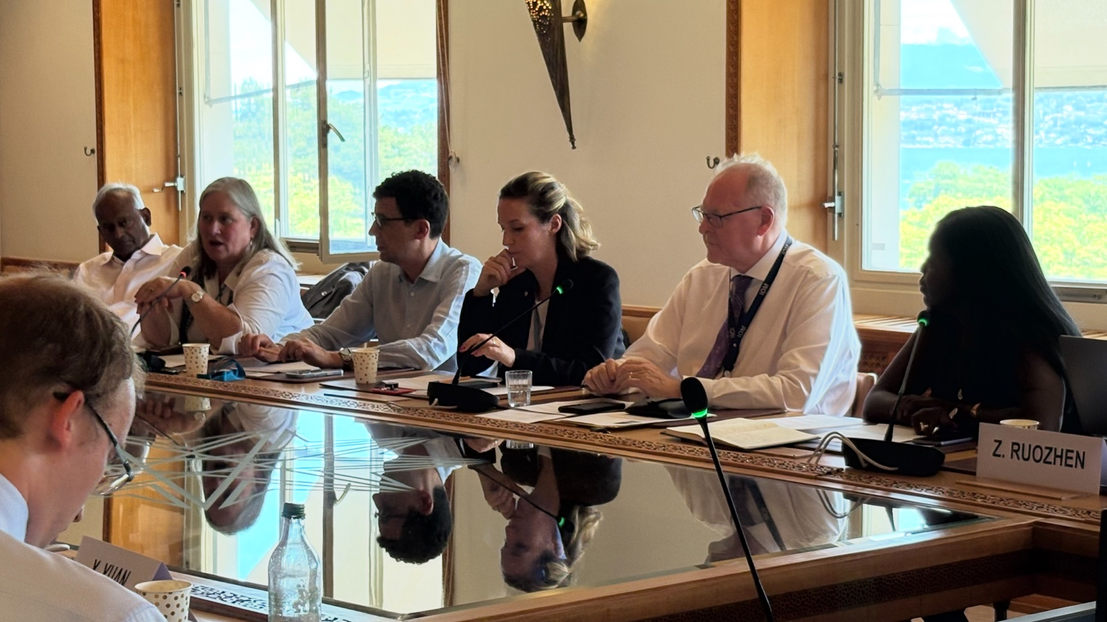
Panel Discussion
Ms. Muscroft opened by observing that the drivers and structure of humanitarian crises had changed substantially. Climate-related catastrophes increasingly occurred on top of displacement, political instability, conflict, and other complex emergencies. She cited the situation in Venezuela, where a longstanding displacement and political crisis had been compounded by a catastrophic earthquake, as an example of the overlapping or cumulative character of contemporary crises.
She also identified a gradual shift in the normative framework governing humanitarian action and Member-State accountability. Drawing on her experience of the Syrian conflict, she noted that humanitarian organizations had been compelled to cross previously established operational boundaries and negotiate access through governments, non-state armed groups, and highly contested political environments. Humanitarian access itself became the grounds for a “proxy war,” entangled in the geopolitical confrontation among external powers, while organizations had to work pragmatically wherever access could be secured in order to reach affected populations.
A further major disruption followed the change in the United States administration in early 2025 and the rapid dismantling of USAID operations and humanitarian financing. The speed of this shift produced an immediate shock across the sector. It also accelerated a broader trend in which Member States redirected overseas development assistance toward national security and defense priorities. Humanitarian organizations were consequently among the first and most severely affected parts of the international system. Ms. Muscroft estimated that many organizations had reduced their capacity by approximately one-third, while some international NGOs had ceased operating altogether.
Ms. Muscroft described the humanitarian sector’s response through the framework articulated by UN Emergency Relief Coordinator Tom Fletcher. This “humanitarian reset” can be summarized across four principal directions: defining, delivering, decision-making, and defending.
First, humanitarian organizations had to define their core responsibilities more precisely. With fewer resources and reduced institutional capacity, humanitarian response plans were being “hyper-prioritized” around immediate life-saving needs. This did not imply that long-term recovery and development needs were unimportant, but rather that humanitarian actors could no longer assume responsibility for the full range of needs within affected societies.
Second, delivery needed to become more agile, flexible, adaptive, and coordinated. Ms. Muscroft rejected the suggestion that organizations could simply “do more with less.” The more realistic objective was to do better with the resources that remained while continuing to advocate for unmet needs.
Third, decision-making had to be devolved toward communities, national authorities, and regional organizations. International response would remain necessary in large-scale crises, but it should be calibrated differently and should build local, national, and regional capacity before defaulting to internationally directed operations.
Fourth, the humanitarian space itself had to be defended. Ms. Muscroft noted that the preceding three years had been the deadliest recorded period for humanitarian personnel, with more than 1,000 humanitarian workers reportedly killed in the line of duty. She stated that many of these deaths had resulted from the actions of Member States and called for stronger accountability when governments disregarded established humanitarian norms.
Mr. Emery connected this contraction directly to the experience of IOM. He said that the IOM had separated approximately 7,000 staff within a three-month period, amounting to roughly one-third of its workforce. Those who remained were often expected to maintain comparable workloads with substantially fewer colleagues. From a human-resources perspective, this had contributed to significant increases in stress and had led some experienced personnel to leave the humanitarian sector voluntarily because the demands of the work had become untenable.
Mr. Blanc reported similarly severe reductions at UNHCR. Approximately 5,500 staff had been lost during the preceding year, with a further 1,000 reductions anticipated. He emphasized that the consequences could not be measured solely in headcounts. Organizations were also losing technical expertise, management capacity, field knowledge, and institutional memory accumulated over many years. This made it substantially more difficult to achieve the efficiencies that restructuring was ostensibly intended to produce.
Ms. Douilliez stated that IFRC had experienced reductions of approximately 20 to 25 per cent. Although reform had already been underway before the changes in U.S. policy, the dismantling of USAID had accelerated that process at an unprecedented speed. The Federation had consequently been required to reassess its priorities and refocus on its core functions.
Ms. Jah added that humanitarian crises were intensifying at the same time that the system’s capacity was shrinking. Reform therefore had to involve not only institutional reduction, but also the mobilization of local resources, stronger state commitments, greater inclusion, and a reconsideration of how the humanitarian system was structured. She linked this agenda to the commitments made under the Grand Bargain concerning localization and more effective humanitarian financing.
Ms. Douilliez addressed the implications of reform for locally led humanitarian action. The humanitarian reset sought to ensure that local actors and governments were not merely involved in implementation but were placed at the center of decision-making at country and community levels. Communities themselves were already the principal drivers of many responses, and the policy commitment to localization had been articulated as early as the 2016 Grand Bargain. Implementation, however, remained incomplete.
She illustrated institutional reform through the integration of humanitarian functions related to shelter, housing, collective centers, camps, and site management. Functions that had previously been organized through separate silos were being brought together under a common structure led by IOM and IFRC. The objective was to develop common strategies with relevant ministries and local authorities, reduce duplication, improve geographic coverage, and combine the comparative strengths of participating organizations.
Responsibility for coordination was also increasingly being transferred to national actors. Following the 2015 Nepal earthquake, for example, IFRC had gradually handed leadership of the shelter cluster to the Nepal Red Cross, which now worked directly with public authorities during recurring emergencies. Similar arrangements were being pursued in Vanuatu, the Solomon Islands, Bangladesh, and Indonesia.
Ms. Douilliez cautioned, however, that localization could result in the transfer of risk rather than genuine empowerment. When international organizations closed offices or withdrew funding, local actors could inherit responsibility for coordination and decision-making without receiving the financial resources, institutional protection, or technical support needed to carry out those functions. Although the Grand Bargain had committed the sector to directing 25% of humanitarian funding to local actors, actual allocations remained far below that target. Donor compliance and due-diligence requirements frequently prevented governments from transferring funds directly to local organizations. Her priority for reform was therefore to make local leadership operationally and financially real, rather than continuing to treat it as a rhetorical aspiration.
Discussion
For the first question, Dr. Franz Baumann asked a two-part question: first, how IOM had selected the approximately 7,000 staff whose employment had ended and, second, whether appropriate local actors could always be found in an extreme emergency such as Sudan.
Responding to the first inquiry, Mr. Emery explained that IOM differed from many other international organizations because it was largely project-funded. When a project ended, the employment attached to it generally ended as well. IOM’s largest program had been the United States Refugee Admissions Program, which employed approximately 5,200 people. Following stop-work orders issued in January 2025, around 5,100 personnel were separated from that project, while several thousand others were affected across additional U.S.-funded projects.
Reductions in project income also affected core funding and headquarters functions. Departments were assigned reduced financial envelopes and allowed to determine how to meet them. Some positions were eliminated, while approximately 100 posts were moved from Geneva to lower-cost locations, principally Thessaloniki, Athens, Valencia, and other regional offices. Other personnel entered part-time or job-sharing arrangements. Mr. Emery described these measures as preferable to uniform dismissals, but nevertheless painful for the staff affected.
Ms. Douilliez responded to the second question, saying that even in Sudan there were hundreds of local civil-society organizations, community networks, and locally led institutions. The Sudanese Red Crescent was among the most prominent, but numerous medium-sized and grassroots organizations also operated with support from diaspora communities, international organizations, and public sources. OCHA-managed pooled funds had helped direct funding toward such actors.
Ms. Muscroft argued that localization required more than transferring money to individual NGOs or inviting them into coordination meetings. The entire local system, including national and local governments, civil society, women-led organizations, and private businesses, needed to be mobilized and supported. She acknowledged that strong national structures could have both positive and negative consequences. Government institutions provided necessary counterparts but could also be highly controlling or politicized and might obstruct humanitarian engagement with communities located in areas controlled by opposing armed groups. Sudan illustrated the difficulty of navigating between rival authorities while maintaining access and neutrality. Women-led organizations were particularly important but were also often among the first to lose resources when funding contracted.
The principal weakness of localization is, therefore, not an absence of local actors, but the unwillingness or inability of international organizations and donors to transfer genuine decision-making power. Local organizations need to help design and direct responses, not merely participate in meetings or implement externally determined plans. Donors similarly need to undergo their own “reset” by coordinating investments more effectively and adapting their systems to provide sustainable support to local institutions.
Dr. Xinyu Yuan asked how the UN system could respond to the persistent obstruction of humanitarian access and whether alternative donors, including Gulf states, China, emerging economies, and private businesses, possessed the willingness and capacity to fill the growing resource gap.
Mr. Blanc cited approximately 100,000 refugees stranded near the border between South Sudan and Ethiopia, whom humanitarian organizations had been unable to reach fully for at least one month. He argued that the contraction of humanitarian support involved not only money and personnel but also political leverage. In the past, diplomatic engagement by the United States, European states, and Japan had helped humanitarian agencies negotiate access. Their reduced interest and influence made it more difficult to compel governments and other authorities to permit humanitarian operations. Without access, additional funding could achieve little. He noted that UNHCR and other organizations had long sought partnerships with corporations and private donors, including companies such as Uniqlo. Humanitarian organizations were therefore not beginning donor diversification from nothing. Nevertheless, competition for private support was intense because many organizations and crises were seeking attention simultaneously.
Ms. Jah cited the response to the Myanmar earthquake as an example of funding being available while access remained blocked. Humanitarian actors received resources but were unable to reach affected communities because access had become politicized under de facto authorities. High-level advocacy did not fully resolve the problem. Humanitarian reform needs to address the political conditions within which aid operates, rather than treating financing and delivery as separate technical questions.
Professor Vesselin Popovski asked how international organizations selected local partners and ensured that transferred resources were used responsibly.
Ms. Muscroft described country-based pooled funds, managed by OCHA on behalf of the humanitarian community, as one of the principal mechanisms for supporting local and national actors. Organizations receiving funding were vetted and subjected to defined monitoring, evaluation, and accountability requirements. She stated that, additionally, the United States was reinvesting approximately US$3.8 billion in the humanitarian sector, much of it through pooled-fund arrangements. Because the United States had imposed additional conditions, the funding was managed through a parallel window supported by global and local accountability and impact teams across 23 countries. Ms. Muscroft characterized the country-based pooled-fund mechanism as one of the sector’s most highly accountable financing arrangements.
At the same time, she acknowledged that newly established local organizations did not always possess mature governance, dispute-resolution, financial-management, or compliance systems. International partners, therefore, had to invest in the development of those systems rather than expecting local actors immediately to meet standards that larger institutions had developed over decades.
Mr. Blanc added that the selection and development of local partners could take years. Organizations might deliberately work with refugee-led, women-led, or community-based groups that did not initially possess extensive institutional capacity but represented their communities effectively. The objective was to build sustainable capacity over several years. Localization could nevertheless fail when international funding was suddenly withdrawn and a partner organization collapsed after years of investment.
Dr. Arbenita Sopaj asked whether the humanitarian system had learned that it could not remain excessively dependent on a small number of major donors (e.g., the USA). She asked whether Japan, the Republic of Korea, Middle Eastern states, and other middle powers could help create greater predictability.
Ms. Muscroft responded that approximately 40% of the humanitarian sector had previously been funded by the United States through USAID. This financial dependence created vulnerability, but it also shows the generosity of the United States. Past U.S. support brought not only financial benefits; it also delivered extensive technical and operational expertise. Humanitarian organizations already receive support from Japan, Middle Eastern states, Brazil, the private sector, and other sources. The present difficulty is not only that the United States has reduced funding, but that governments are redirecting resources toward defense and security across many donor states.
Ms. Muscroft emphasized the political power of coalitions of smaller states. She noted that some major multilateral achievements had been driven by smaller Member States acting collectively and then compelling larger powers to engage. Smaller and middle-power states could similarly play a stronger role in protecting humanitarian norms, exercising diplomatic pressure, and contributing to emergency response.
Professor Sheng Hongsheng highlighted China’s contributions to refugee protection and humanitarian response, including assistance to displaced populations from Viet Nam and Myanmar.
Ms. Muscroft acknowledged China as an important humanitarian partner and a leader in emergency first response, including through international search-and-rescue networks and assistance following the Myanmar earthquake.
Professor Zhang Guihong proposed that humanitarian assistance might be recognized more explicitly alongside the established UN pillars of peace and security, development, and human rights. He also asked how humanitarian organizations coordinated with the peace-and-security architecture and the development system through the humanitarian-development-peace nexus.
Ms. Muscroft responded that humanitarian action was already treated as a central area of UN work and was institutionally reflected in the existence of OCHA. Humanitarian principles and sectoral activities were founded upon human rights, including refugee law and rights relating to shelter, protection, and assistance. At the same time, OHCHR played a broader role in normative development and treaty-based human-rights work that differed from emergency humanitarian operations. The institutions already cooperated closely, including through protection-cluster arrangements, although additional efficiencies could be found.
She explained that the humanitarian-development-peace nexus had been discussed for decades, including through the Brahimi Report and experiments with integrated UN missions. Her own experience in Sierra Leone illustrated efforts to place political, humanitarian, recovery, and development work under more coherent leadership. The UN had accumulated substantial experience, but no single model worked in every context. Under constrained resources, it was particularly important to avoid duplication and to distinguish immediate humanitarian responsibilities from longer-term development functions.
Ms. Jah emphasized that nexus-based action required collaboration not only among humanitarian, development, and peace actors, but also with donors. Funding structures frequently separated short-term humanitarian assistance from medium- and long-term recovery. She cited emerging nexus-oriented funding approaches supported by Japan and the Republic of Korea and argued that recovery, resilience, and exit strategies should be considered from the beginning of a response. In Sudan, for example, populations were already returning to areas such as Khartoum despite the continuation of active conflict. Humanitarian actors therefore had to respond to immediate needs while also considering stabilization, reintegration, and the resilience of returning communities. Nexus policy would remain theoretical unless accompanied by appropriate financial instruments, coordination mechanisms, and operational investments.
Professor Hasegawa asked about the relationship between the UN Resident Coordinator and Humanitarian Coordinator functions and about the respective roles of the ICRC and IFRC.
Ms. Douilliez explained that ICRC takes the operational lead within the Red Cross and Red Crescent Movement in armed-conflict contexts. IFRC primarily supports and coordinates the 191 national societies and generally works through them rather than implementing directly. In Rwanda, for example, ICRC would have exercised the leading conflict-related role, while IFRC would have supported the Rwandan Red Cross and coordinated assistance from partner national societies. She compared IFRC’s coordinating role within the Movement to OCHA’s role within the wider humanitarian system.
She explained that Resident and Humanitarian Coordinators generally exercise authority through convening and “soft power,” rather than direct command. The Humanitarian Coordinator represents the Emergency Relief Coordinator under General Assembly resolution 46/182 and coordinates not only UN agencies but also non-UN humanitarian organizations and donors through the wider humanitarian architecture.The Resident Coordinator and Humanitarian Coordinator roles were now usually combined. Separate appointments remained possible when political circumstances or competency requirements warranted them, while Deputy Humanitarian Coordinators could be appointed to provide additional operational capacity.
Professor Sudarshan Ramaswamy asked how humanitarian organizations worked with religiously affiliated local actors that might provide valuable assistance while also reproducing communal exclusion or discrimination.
Ms. Douilliez responded that the fundamental Red Cross and Red Crescent principles required assistance to be impartial and independent of ethnicity, religion, or political identity. Nevertheless, all humanitarian personnel and institutions operated within social and cultural contexts and carried their own beliefs. The appropriate response was not necessarily to demand that every organization possess equal access to every community, but to coordinate the available actors so that their different relationships and capacities complemented one another. Mapping who could operate effectively in particular communities could help ensure that all affected groups received assistance without requiring every organization to perform the same role.
Dr. Jamie Pring asked about cooperation with regional organizations, the reconciliation of humanitarian principles with other UN norms, and areas in which academic research could contribute to humanitarian practice.
Ms. Jah described regional and subregional organizations as increasingly important partners for advocacy, policy development, access, and operations. In Asia, the UN worked with ASEAN and its AHA Centre. In Africa, cooperation with the African Union extended across humanitarian response, displacement, peace, development, and security. She also emphasized the importance of engaging local and customary institutions in transitional justice, reparations, restitution, reconciliation, and peaceful coexistence.
As a research priority, Ms. Jah identified climate change as a multiplier of humanitarian crisis. She called for stronger research on anticipatory action, forecasting displacement and mass movement, the relationship between climate and security, the increasing frequency of disasters, and models of intervention capable of responding to overlapping emergencies.
Mr. Emery added that research on the effect of recent institutional contraction and crisis intensity on the stress and well-being of humanitarian personnel would also be valuable.
Ms. Yuriko Shoji asked whether cooperation differed between national and subnational levels, whether the humanitarian system’s contraction represented an erosion of its principles, and whether humanitarian action was becoming increasingly transactional.
Mr. Emery responded that humanitarian and multilateral work had never been more relevant, even though it had rarely been under greater pressure. The sector needed younger professionals capable of approaching longstanding problems differently. He expressed concern that norms built over decades, including human rights, gender equality, diversity, equity, and inclusion, were facing increasing resistance without sufficiently strong defense from Member States.
Ms. Muscroft explained that humanitarian actors maintained strategic dialogue with national authorities through Resident and Humanitarian Coordinators while working pragmatically with communities at the local level. Local actors needed to be fully integrated into area-based coordination and placed at the forefront of response design. She nevertheless stressed that international humanitarian capacity would remain necessary. Responsibility and risk could not be transferred entirely to national organizations, particularly when local systems were overwhelmed by multiple crises. The international system needed to remain agile enough to intervene when required and disciplined enough to withdraw or hand over responsibility in a manner that left resilient local structures in place.
Mr. Emery asked Ms. Muscroft what she thought humanitarian action should look like ten years from now. She said that she envisioned a more agile and diverse system, less dominated by a small number of large donors and more strongly shaped by smaller states, national organizations, and regional institutions. International structures would continue to play a role, but more robust national and regional capacity should be placed at the center of response.
Mr. Emery then asked the remaining panelists how emerging technologies, particularly artificial intelligence, might shape that future.
Mr. Blanc stated that AI was already being explored for emergency preparedness, administrative work, drafting, reporting, and predictive scenario development. UNHCR personnel were working with universities and other UN agencies on models that could help organizations conceptualize emergencies, improve preparedness, and engage governments, financial institutions, and other stakeholders before a crisis escalated.
Ms. Douilliez emphasized that AI could improve prediction, needs analysis, and information processing. Its use also raised serious questions about the security and vulnerability of data concerning at-risk populations. Digital inequality remained an additional concern: humanitarian organizations could not assume that communities without reliable electricity or connectivity would benefit equally from AI-enabled systems. Innovation therefore had to be pursued without leaving already difficult-to-reach populations further behind.
Ms. Jah proposed deeper collaboration with universities and research institutions to co-create evidence-based models and apply large datasets to preparedness and crisis forecasting. The UN did not possess all necessary research capacity internally, and external partnerships could strengthen its ability to anticipate and respond. She also predicted a growing role for private businesses, not only as financial contributors but as sources of technology, logistics, infrastructure, and operational capacity. Companies such as Amazon and Airbnb had already contributed directly to humanitarian responses, sometimes acting before traditional donors. As an example, Mr. Emery recalled that Airbnb had reportedly mobilized approximately 100,000 temporary rooms or accommodations for people displaced by the conflict in Ukraine.
Professor Sheng Hongsheng offered a final comment, emphasizing the importance of promoting humanitarianism more widely through education, professional training, and intercultural engagement. Finally, Mr. Emery closed the session by thanking the panelists and observing that, despite their different institutional perspectives, they were confronting many of the same pressures, challenges, and opportunities.

Session 4: ITU’s Overview, Mission, and Impact of ITU Work in the Global Ecosystem
Professor Sukehiro Hasegawa opened the session by inviting the representatives of the International Telecommunication Union (ITU) to provide an overview of the organization before proceeding to an interactive discussion with members of the Asian Scholars’ Dialogue. The ITU delegation comprised Mr. Emmet Ryan, ITU Study Group Adviser; Ms. Ana Tabacaru; Mr. Sergio Buonomo; and Ms. Alicia Soto Romero. Mr. Ryan delivered the principal presentation, while Ms. Soto Romero contributed to the subsequent discussion on gender inclusion within ITU processes.
Mr. Ryan introduced ITU as the United Nations specialized agency for digital technologies and information and communication technologies. Established in 1865 as the International Telegraph Union, it was renamed the International Telecommunication Union in 1932 and became a UN specialized agency in 1949. Over more than 160 years, its purpose has remained consistent: enabling communication systems developed in different jurisdictions to interconnect and function across borders.
ITU performs three central functions: 1.) it coordinates the global use of the radio-frequency spectrum and satellite orbits; 2.) develops technical standards that allow networks, services, and devices to operate together; and 3.) supports the expansion of affordable and inclusive digital connectivity. Mr. Ryan emphasized that many ordinary activities, including telephone calls, internet access, email, satellite navigation, weather forecasting, broadcasting, transportation, and maritime communication, depend upon standards or spectrum arrangements developed through ITU.
The ITU operates as a multilateral platform bringing together governments, private companies, universities, and research institutions. Its membership includes 194 Member States, more than 1,300 private-sector entities, and over 170 academic and research institutions. This broad membership enables technical standards and regulatory frameworks to draw upon government authority, industry expertise, and academic research. ITU also maintains regional offices across the world, allowing its activities to reflect different national and regional circumstances.
Mr. Ryan explained that ITU is organized into three sectors:
- ITU-T, the Telecommunication Standardization Sector, develops international technical standards for wired networks, digital services, security, multimedia, and emerging technologies.
- ITU-D, the Telecommunication Development Sector, supports affordable and equitable access to digital technologies, particularly in developing countries and underserved communities.
- ITU-R, the Radiocommunication Sector, coordinates the use of the radio-frequency spectrum and satellite-orbit resources.
ITU-T standards take the form of recommendations developed by technical study groups and approved through consensus-based processes. Although generally non-binding, they are widely observed because they enable interoperability and economies of scale. International telephone-numbering arrangements provide a simple example: without an agreed numbering structure, international telephone calls could not be routed reliably among national networks.
ITU-D works to connect populations that remain excluded from digital systems. Its activities include policy assistance, technical support, statistics, institutional capacity-building, and training through mechanisms such as the ITU Academy. Its focus is not only on physical connectivity but also on the ability of developing countries and underserved communities to use digital technologies for social and economic development.
Mr. Ryan devoted particular attention to ITU-R and the governance of the radio-frequency spectrum. The spectrum is a finite natural resource upon which an expanding range of communication, scientific, commercial, transportation, and security systems depend. Every radio-based system requires a transmitter and receiver operating on an agreed frequency. When incompatible systems use the same frequency without coordination, harmful interference can interrupt or disable communication.
ITU-R therefore seeks to ensure the rational, equitable, efficient, and economical use of the spectrum and satellite orbits. Its task is not to assign individual domestic licenses, but to establish the international framework within which national systems can coexist without harmful interference.
The foundation of this framework is the Radio Regulations, an international treaty governing the use of the spectrum and geostationary and non-geostationary satellite orbits. The Regulations are binding on ITU Member States and are revised through World Radiocommunication Conferences held every four years. Mr. Ryan noted that 2026 marked the 120th anniversary of this regulatory framework and that its most recent edition had been published in 2024.
For allocation purposes, the world is divided into three regions: broadly, Europe, Africa, the Middle East, and northern Asia; the Americas; and most of Asia and the Pacific. Different regions may use particular frequency bands differently because of historical patterns, existing infrastructure, and local needs. The purpose of the Regulations is to ensure that these differences remain coordinated, especially between neighboring countries.
The allocation table extends from 9 kilohertz to 300 gigahertz and encompasses 54 categories of radiocommunication service. Virtually every part of the spectrum is already allocated, and most bands are shared among several services. Managing compatibility among these uses requires continuous technical study and international negotiation.
Technical work within ITU-R is conducted through six study groups:
- Study Group 1 addresses spectrum-management principles, techniques, and tools.
- Study Group 3 studies radio-wave propagation and the scientific behavior of signals.
- Study Group 4 addresses satellite services.
- Study Group 5 covers terrestrial services, including mobile, maritime, aeronautical, navigation, amateur, and related systems.
- Study Group 6 addresses broadcasting services.
- Study Group 7 covers scientific services, including space research, Earth-observation satellites, meteorology, time signals, and radio astronomy.
Because scientific measurements can be extremely sensitive to interference, particular care is required to protect frequencies used for weather forecasting, climate monitoring, space research, and radio astronomy. A separate coordination mechanism helps ensure consistent technical vocabulary across study groups, which is especially important where standards and treaty language require precise common definitions.
Mr. Ryan illustrated how ITU-R’s work supports essential public and economic functions. Radiocommunication systems are indispensable for public protection, disaster response, and search-and-rescue operations, particularly when terrestrial infrastructure has been damaged or is unavailable.
ITU also develops the technical foundations for successive generations of international mobile telecommunications. Its standards and spectrum arrangements have supported the transition from analogue systems to 2G, 3G, 4G, and 5G. Harmonization allows devices to operate across national boundaries and enables manufacturers to produce equipment and chipsets at global scale.
ITU standards similarly underpin aircraft tracking, air-traffic management, maritime distress and safety systems, intelligent transportation, satellite navigation, broadcasting, the Internet of Things, weather monitoring, and scientific observation. These services may appear unrelated, but all depend upon predictable access to frequencies and protection from harmful interference.
Looking toward the 2030s, ITU studies are already addressing 6G, including the integration of terrestrial and non-terrestrial networks. The aim is to enable more seamless coverage across conventional mobile infrastructure and satellite systems. Work also extends to electromagnetic-field exposure, accessibility, emergency telecommunications, rural connectivity, digital health, smart grids, and the environmental effects of ICTs.
The rapid expansion of space activity was identified as one of ITU’s most significant emerging challenges. Low Earth orbit, extending approximately 400 to 2,000 kilometers above the Earth, had experienced particularly rapid growth. Mr. Ryan reported that more than 8,000 active satellites were operating in low Earth orbit in 2024, representing approximately 90 per cent of active satellites at that time. The number was continuing to increase as falling launch costs enabled the deployment of large commercial broadband constellations.
These systems could expand global connectivity, reduce latency, strengthen network resilience, and provide service to remote or underserved regions. At the same time, their proliferation increased the complexity of spectrum coordination, orbital congestion, interference management, and long-term space sustainability.
Large non-geostationary constellations such as Starlink required coordination not only with one another but also with existing terrestrial and satellite systems. Each additional satellite and constellation increased the number of technical relationships that had to be assessed. ITU was also studying direct-to-device communication, through which satellites could communicate directly with ordinary mobile devices in locations without terrestrial coverage.
Other areas of study included intelligent transport systems, modernized aeronautical communications, lunar communications for future scientific and exploration activities, protection of radio-quiet zones, and safeguarding frequencies used for Earth observation and climate monitoring. Mr. Ryan concluded that space radiocommunication had become a central component of global information infrastructure and that international coordination would become more—not less—important as terrestrial and satellite networks converged.

Discussion
Ms. Motoko Mizuno opened the discussion by asking whether artificial intelligence fell within ITU’s mandate and, if not, which part of the UN system was responsible for governing it.
Mr. Ryan explained that ITU convened the AI for Good platform, which brought together governments, industry, academia, civil society, and more than 40 UN entities. The platform sought to identify practical applications of AI that could advance the Sustainable Development Goals and to encourage cooperation across sectors. ITU also monitored the development of national AI strategies and supported evidence-based policy discussions. Its membership had not, however, given the Organization a formal mandate to regulate AI. Its principal role was therefore convening, technical cooperation, and standardization rather than comprehensive legal regulation.
Professor Hasegawa asked whether any other UN entity possessed such regulatory authority over AI.
Mr. Ryan responded that he was not aware of a UN agency with a comprehensive mandate to regulate AI and observed that the pace of technological development made it difficult for conventional regulation to keep up.
Dr. Xinyu Yuan noted UNESCO’s visible role in the ethics of AI and asked whether different UN entities were competing for leadership in global AI governance.
Mr. Ryan explained that UNESCO was one of the participating agencies in AI for Good. Because AI affected technical infrastructure, ethics, education, culture, development, security, and human rights, no single institution could address all aspects of it. ITU’s comparative advantage lay principally in technical systems and connectivity, while ethical and social dimensions properly involved other organizations.
Dr. Yuan also asked whether ITU addressed online scams, a growing concern in East and Southeast Asia.
Mr. Ryan explained that this subject lay outside his own ITU-R responsibilities. It might, however, be addressed through ITU-T work on cybersecurity, network integrity, or related standards, and he offered to consult the relevant technical colleagues rather than provide an uncertain answer.
Mr. Tanimoto asked whether the increasing integration of ITU-R and ITU-T standards could impose an excessive regulatory burden on states.
Mr. Ryan distinguished among different categories of ITU outputs. The Radio Regulations carry treaty status and are binding on Member States. ITU-R and ITU-T recommendations are generally non-binding technical standards. The two sectors coordinate closely to avoid duplicated or conflicting requirements, and proposed work is redirected when it falls more appropriately within another sector. National governments retain sovereignty over domestic implementation. They determine, for example, how frequencies are licensed, how broadcasting is regulated, and how particular radio services are administered. ITU standards provide the basis for international compatibility, but they do not eliminate domestic discretion.
Ms. Lauren Power referred to ITU’s current partnerships on digital gender inclusion (e.g., EQUALS and with GSMA) and asked how this work could be extended into making AI work for good.
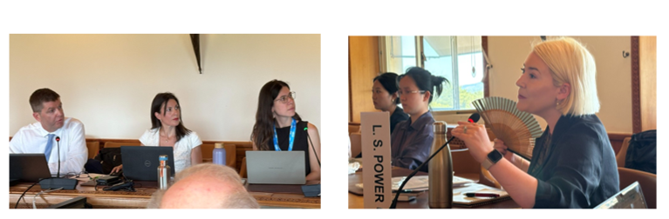
Ms. Alicia Soto Romero explained that ITU had developed platforms intended to increase the participation and leadership of women in its technical processes. The Network of Women supported women seeking leadership positions within study groups and working parties. A gender declaration had been adopted at the 2019 World Radiocommunication Conference, followed by a further resolution on gender equity, parity, and inclusion at WRC-23. The Network of Women met during major ITU events and supported mentoring relationships between experienced chairs, ITU personnel, and women entering technical and leadership roles. Although Ms. Soto Romero did not predict the outcomes of the ongoing AI for Good Summit, but she emphasized that gender inclusion was already being integrated into ITU’s institutional structures.
Professor Sheng Hongsheng reflected on his own reliance on radio and satellite communications during UN field service and raised concerns about the militarization and weaponization of outer space.
Mr. Ryan noted that ITU’s mandate related to the use of radio frequencies and satellite orbits rather than the broader prohibition of weapons in space.
Professor Hasegawa then asked whether international organizations possessed sufficient authority to enforce existing rules when Member States chose to disregard them.
Mr. Ryan responded that the ITU framework ultimately depended upon Member States honoring the treaty obligations they had accepted. ITU maintained procedures for reporting harmful interference and could provide a technical forum through which affected and allegedly responsible states attempted to resolve disputes. An international monitoring system could help identify the origin of interfering signals. Moving a dispute from a highly politicized setting into a technical process sometimes made an agreed solution more achievable, but ITU did not possess an independent coercive enforcement mechanism.
Ms. Mizuno, drawing upon her experience with the Japan Aerospace Exploration Agency, asked how ITU could manage the rapidly increasing volume of satellite-coordination applications. She also raised questions concerning the commercial sale of frequencies, solar-power satellites, and intentional jamming.
Mr. Ryan acknowledged that satellite coordination had become extraordinarily complex. Large constellations required the assessment of orbital trajectories, frequencies, existing filings, and potential interference with many other systems. ITU was investing resources in reducing application backlogs and processing times. AI and improved computational tools might eventually assist with these calculations, but the technical problem remained considerably more complex than a simple automated comparison.
On spectrum pricing, he explained that domestic licensing and auctions fell within national sovereignty. ITU coordinated international allocations but did not sell frequencies or determine the price at which governments licensed domestic spectrum.
The potential transmission of solar energy from space might enter ITU’s remit if radio-frequency emissions created interference, although the technology also raised issues beyond the conventional radio spectrum and outside ITU’s immediate jurisdiction.
Regarding military installations, Mr. Ryan referred to Article 48 of the ITU Constitution. States retain substantial freedom over military radio installations but are expected, as far as possible, to observe international radio regulations. Cases of deliberate jamming could be reported through ITU mechanisms and might be referred to the Radio Regulations Board. Resolution would nevertheless remain difficult in an openly hostile political context, and enforcement continued to depend heavily upon Member-State cooperation.
Dr. Yuna Lee asked how discussions within AI for Good influenced ITU standards and what the greatest challenge would be in maintaining interoperability as communication systems evolved toward AI-native 6G and satellite networks.
Mr. Ryan explained that formal standardization remained membership driven. Discussions at AI for Good could inform new ideas, but technical standards were developed when Member States or sector members submitted contributions proposing a defined area of study. Other members then contributed evidence and technical analysis through the study-group process. AI applications could therefore enter ITU standards progressively as their technical uses became clearer. He identified the accommodation of large satellite constellations as one of the most pressing contemporary challenges. Their scale had not been anticipated when many existing coordination processes were designed. AI might itself become part of the solution by improving spectrum analysis, network monitoring, and the management of increasingly complex filings.
Ms. Jiang Junji asked how radiocommunication governance related to wider AI governance and how the UN system could prevent institutional fragmentation.
Mr. Ryan explained that the growth of AI would increase demand for data centers, mobile infrastructure, satellite connectivity, and spectrum. Older or less intensively used services would face greater pressure as governments and industries sought frequencies for new applications. ITU-R’s contribution to inclusive AI development would therefore include making communications infrastructure more efficient and expanding access to the connectivity required to use AI systems. AI for Good could also serve as a coordinating forum across the UN system. Harmonization had been essential to the success of global mobile communications, and a similar commitment to cooperation would be needed to avoid fragmented AI systems and incompatible standards.
Professor Sudarshan Ramaswamy asked whether the rapid expansion of privately operated satellite constellations, particularly those associated with Elon Musk, posed a threat to the rules-based system that ITU had developed since 1865.
Mr. Ryan declined to comment on any individual corporate leader. He emphasized, however, that private operators were subject to national regulatory systems and that their satellite filings had to proceed through the relevant Member-State administration. Companies associated with these satellite systems participated as ITU sector members and were therefore familiar with its procedures.
When Professor Hasegawa asked about the number of satellites in orbit, Mr. Ryan estimated that the number in low Earth orbit had probably risen from the previously cited 8,000 to closer to 10,000. Every proposed satellite constellation still required notification of its orbital characteristics and frequency use, although the scale of anticipated future filings posed a serious administrative and technical challenge.
Professor Hongsheng asked about space debris. Mr. Ryan clarified that the physical management of orbital debris did not fall under ITU’s mandate, although debris could plainly affect satellites and communications systems.
Dr. Franz Baumann observed that ITU had 194 Member States while the United Nations had 193. The discussion indicated that the difference arose from the membership of the Holy See, which participates in ITU while holding observer-state status at the United Nations.
Dr. Jamie Pring asked which technical or political issues presented the greatest compliance problems and whether ITU was affected by the wider financial contraction within the UN system.
Mr. Ryan estimated that approximately 85% of ITU funding came from membership contributions, supplemented by cost-recovery fees associated with services such as satellite filings and specialized publications. Its diversified membership-based financing distinguished it from organizations that depended predominantly upon voluntary humanitarian or project funding. Persistent or deliberate interference remained among the most difficult compliance problems. ITU’s International Monitoring System allowed participating national stations to help identify the geographical source of interfering transmissions. The expectation was then that national regulators and authorities would cooperate to resolve the problem.
Mr. Ryan illustrated the value of this system through an incident involving a maritime emergency-position-indicating radio beacon. The discarded device had been placed in a refuse site and repeatedly activated whenever rainwater triggered its emergency mechanism. The resulting transmissions diverted the attention of search-and-rescue authorities. International notification and national investigation eventually enabled the source to be identified and the interference ended. The example demonstrated that interference could have serious operational consequences even when it was accidental rather than hostile.
Professor Hasegawa closed the session by thanking the ITU representatives for the presentation and discussion.

18:30 Dinner reception by the Japanese Permanent Mission
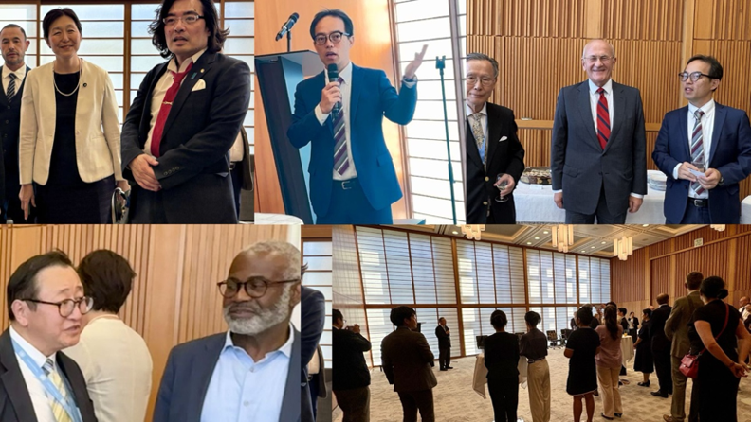

Day 2. Tuesday, 7 July 2026

Promenade along Lac Leman to the World Trade Organization

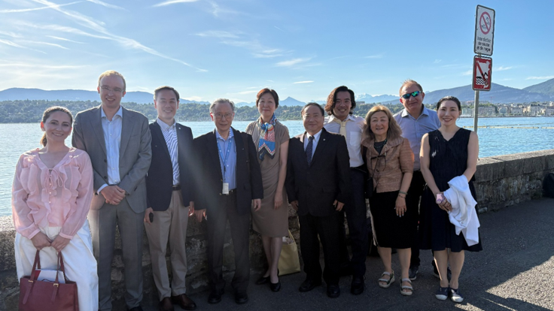

Session 5: World Trade Organization
5.1: Briefing by WTO Deputy Director-General Zhang Xiangchen
The delegation was received at the World Trade Organization by Dr. Zhang Xiangchen, Deputy Director-General of the WTO, who provided a wide-ranging assessment of the international trading system, the geopolitical pressures confronting the Organization, and the reforms required to preserve the relevance of multilateral trade governance.
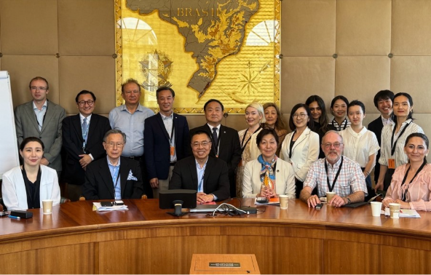
Dr. Zhang welcomed the scholars at what he described as an unusually difficult moment for both the WTO and the wider international system. Although trade officials remained familiar with foundational WTO principles, including most-favored-nation treatment, national treatment, tariff commitments, and negotiated market access, those principles could no longer be assumed to command universal political support. The WTO therefore needed intellectual engagement and guidance from scholars as it reconsidered how multilateral trade rules should respond to geopolitical conflict, technological change, and changing expectations among its members.
Dr. Zhang observed that trade had traditionally been regarded as an anchor capable of stabilizing relations among states. Increasingly, however, trade itself was being portrayed as a source or instrument of geopolitical conflict. He referred to the economic relationship between China and the United States as an example of both tendencies. Trade disputes had intensified political tensions, but trade negotiations had also continued to provide a channel through which the two governments could communicate, make concessions, and reduce the risk of broader confrontation. Bilateral arrangements could therefore have practical value even when they were inconsistent with the tariff commitments and nondiscrimination principles embodied in WTO law. From the perspective of the multilateral trading system, however, Dr. Zhang argued that major economies should ultimately return to their WTO commitments. The WTO remained distinctive because it offered a platform in which states of different sizes and political systems could negotiate rules capable of applying beyond a single bilateral relationship.
Rapid technological development had made the modernization of trade rules increasingly urgent. Dr. Zhang highlighted the Joint Statement Initiative on Electronic Commerce, co-convened by Japan, Australia, and Singapore, which had attracted participation from more than 80 WTO members. He explained that these negotiations represented a more flexible form of rulemaking. Participating members could develop and implement common rules, while the benefits of their commitments might be extended more broadly through the most-favored-nation principle.
Dr. Zhang also discussed the Investment Facilitation for Development Agreement, an initiative he had helped launch while serving as China’s ambassador to the WTO. Its purpose was to increase the transparency and predictability of investment regimes, establish more efficient administrative processes, create single-window systems, and reduce unnecessary documentation and bureaucracy. Participation has expanded from approximately a dozen members in 2017 to around 130 members. Nevertheless, a small number of members continued to block the formal incorporation of the agreement into the WTO legal architecture. Dr. Zhang presented this as an example of the difficulty of reconciling broad participation with the WTO’s consensus-based procedures.
Dr. Zhang described reform as an increasingly shared concern among WTO members. The WTO has contributed substantially to the expansion of global trade, but important parts of its institutional structure no longer functioned effectively.
The first area of reform concerns decision-making. Consensus remains central to the WTO and reflects an important democratic principle: formally, each member had an equal opportunity to participate in decisions. At the same time, consensus could be abused when a single member prevented action without demonstrating that a vital national interest was at stake. Dr. Zhang referred to a proposal associated with Singapore for “responsible consensus.” Under such an approach, a member seeking to block a widely supported initiative would be expected to explain the substantive national interest requiring it to do so. The objective would not be to eliminate consensus, but to prevent it from becoming an unrestricted veto that rendered agreement impossible among the WTO’s 166 members.
A second reform debate concerned fairness. Developing and developed members often agreed that the existing system was inadequate, but they diagnosed the problem differently. Developing countries argued that the agreements inherited from earlier negotiating rounds remained imbalanced and that many had not benefited sufficiently from integration into the world economy. Dr. Zhang noted that Africa’s share of global trade remained approximately 3 per cent and that the least developed countries accounted for less than 1 per cent. These figures made it difficult to claim that trade liberalization had distributed benefits evenly. Developed members, meanwhile, argued that existing WTO rules were too limited to address the effects of large economies with distinctive economic structures, particularly China. Questions concerning subsidies, state-owned enterprises, industrial policy, and the relationship between state direction and market competition could not be resolved satisfactorily through rules developed for an earlier period. Dr. Zhang’s position was that these concerns should be negotiated within the WTO rather than pursued through unilateral tariffs and trade wars. The Organization could contribute by placing comparable facts, economic data, and institutional analysis on the table, enabling members to identify both differences and possible common ground.
Development constituted a third major reform question. Although the Doha Round had formally been framed as a development agenda, many of its central negotiations had stalled. Dr. Zhang argued that development should not be reduced to special and differential treatment alone. The more important question was how every area of WTO reform, including digital trade, environmental measures, services, investment, and dispute settlement, could enable developing countries to participate meaningfully and obtain tangible benefits. The challenge was particularly acute in relation to digital transformation. Least developed and lower-income countries often lacked broadband infrastructure, payment systems, finance, regulatory capacity, and skilled personnel. These were legitimate constraints, but physical infrastructure alone would not permit participation in digital trade. Countries also required reliable legal frameworks for electronic contracts, authentication, digital payments, consumer protection, and related matters.
The WTO does not possess the financial resources of the World Bank and cannot directly fund major infrastructure projects. Its comparative advantages lay in regulatory knowledge, legal frameworks, and trade-policy expertise. Dr. Zhang therefore advocated closer cooperation between the WTO, development banks, governments, universities, and the private sector.

Discussion
Professor Hasegawa asked how the nature of trade was likely to change over the following five to ten years and whether digital commerce might enable African economies to increase their currently limited share of global trade.
Dr. Zhang described digital trade as the future of international commerce and stated that digital-related trade already accounted for at least 40% of global trade under some statistical definitions. He believed that African countries possessed substantial potential to participate, provided that they did not wait until every infrastructural and institutional problem had been solved.
He recalled an exchange involving Alibaba founder Jack Ma and African delegates at an e-commerce event in Geneva. Asked how countries lacking infrastructure could participate, Mr. Ma had reportedly responded that countries wishing to enter e-commerce needed to begin immediately; otherwise, they risked remaining permanently excluded. Dr. Zhang used the example to emphasize that participation in negotiations was itself essential. States absent from the negotiating table would eventually be required to comply with rules developed by others. Nigeria was cited as a constructive example of an African country participating actively in e-commerce negotiations rather than waiting to request exemptions after the rules had already been established. In his view, special and differential treatment could provide necessary flexibility, but it could not substitute for direct participation in rulemaking, institution-building, and digital strategy.
Professor Sheng Hongsheng reflected on the benefits China had obtained from WTO accession and expressed concern that trade policy was becoming increasingly politicized. He referred to U.S. unilateral measures, Section 301 actions, allegations concerning forced labor, and the paralysis of the WTO Appellate Body.
Dr. Zhang noted that 2026 marked the twenty-fifth anniversary of China’s accession to the WTO. China had achieved remarkable economic progress during that period, and other WTO members had initially benefited substantially from the opening of the Chinese market. China’s scale and distinctive economic system had nevertheless created challenges that existing WTO rules were not fully equipped to address. Subsidy disciplines were one example. Dr. Zhang did not argue that all Chinese subsidies violated WTO law; rather, he maintained that the rules themselves were too limited and required updating. Trade war measures could not ultimately resolve these structural disagreements. China, the United States, and other major members would eventually need to return to negotiation and develop new rules addressing subsidies, state participation, and industrial policy.
Professor Hasegawa asked about U.S. claims that China had unfairly benefited from identifying itself as a developing country within the WTO.
Dr. Zhang explained that developing-country status in the WTO had historically been based largely on self-declaration. China continued to regard itself politically as a developing country but had sought to distinguish that status from the right to claim special and differential treatment in every negotiation. He stated that the Chinese premier had announced that China would no longer seek new special and differential treatment in WTO negotiations. This allowed China to retain its political identity as a developing country while reserving preferential treatment for more vulnerable economies. Dr. Zhang argued that this removed a longstanding U.S. objection: developed members could no longer justify withholding flexibility from poorer countries on the ground that China would receive the same treatment.
Dr. Xinyu Yuan later asked whether China’s decision had already triggered substantive institutional reform.
Dr. Zhang responded that China was not alone in foregoing such treatment; Brazil, the Republic of Korea, and Singapore had taken comparable positions. The effect was likely to be gradual rather than immediate, but it could help reduce the political obstacles surrounding future negotiations on special and differential treatment.
Professor Vesselin Popovski asked whether the WTO had been successful in enforcing trade rules and resolving disputes.
Dr. Zhang described the original WTO system as highly legalized. Members accepted binding rules, relatively limited transition periods, adjudication by panels and the Appellate Body, and the possibility of authorized retaliation when rulings were not implemented. That model had become increasingly difficult to sustain. The United States would not presently accept the former level of judicial constraint, while many developing countries were also reluctant to enter highly demanding legal commitments in emerging areas. Dr. Zhang therefore suggested that the WTO might move, at least in some fields, toward more flexible or “soft-law” arrangements. Initiatives concerning e-commerce, investment facilitation, the green transition, and digital transformation could begin with less stringent rules and flexible participation. Binding WTO disciplines would remain in place, but newer subjects might initially require experimentation, economic analysis, and practical cooperation before comprehensive legal obligations were developed.
Professor Sudarshan Ramaswamy later asked about the continuing paralysis of the Appellate Body and the use of arbitration as an alternative.
Dr. Zhang explained that the absence of a functioning Appellate Body had not eliminated the entire dispute-settlement system. Members could use arbitration under Article 25 of the Dispute Settlement Understanding. The European Union had initiated what became the Multi-Party Interim Appeal Arbitration Arrangement, or MPIA, as a temporary means of preserving appellate review among participating members. China supported the initiative. The United States initially opposed it, arguing that it recreated the institutional features that had led to its objections to the Appellate Body.
Dr. Zhang nevertheless considered the mechanism successful. It had resolved disputes, including a significant case between China and the European Union in which China accepted an adverse outcome. Although some members initially feared that the arrangement would isolate the United States and reduce the likelihood of comprehensive reform, growing numbers of states had concluded that they could not leave disputes unresolved indefinitely. Japan, initially hesitant, had joined the arrangement, and other members were considering participation. Dr. Zhang stressed that the purpose was not to exclude the United States, but to preserve a functioning channel for adjudication while broader negotiations continued.
Dr. Yuan also asked whether the WTO remained equipped to respond to the securitization and weaponization of trade, particularly where food, technology, and other essential goods were increasingly treated as matters of national security.
Dr. Zhang acknowledged that the assumption that trade automatically produced peace had become difficult to sustain. He referred to Afghanistan, whose participation in WTO processes had once been viewed as evidence that trade integration could support development, women’s economic participation, and institutional normalization. Political change later reversed much of that progress. Trade could contribute to peace, but it could not guarantee it. The WTO therefore needed to be realistic: commercial integration could create supportive conditions for stability, but it could not by itself overcome political collapse, conflict, or authoritarian transformation.
Ms. Motoko Mizuno asked how the present U.S. approach differed from earlier periods in which Washington had also preferred bilateral negotiations, including the U.S.–Japan trade disputes of the 1990s.
Dr. Zhang agreed that the United States had traditionally preferred bilateral bargaining when it believed its economic power gave it greater leverage. During the Uruguay Round, however, the Clinton administration had accepted the Marrakesh Agreement and the WTO dispute-settlement system because the United States was confident that it would benefit from agricultural liberalization, services trade, intellectual-property protection, and litigation under common rules.
The contemporary United States is less confident in the multilateral system and more inclined to rely on unilateral or bilateral power. Dr. Zhang recalled a China–U.S. negotiation in which the American representative had dismissed the WTO as a body of “small potatoes” in Geneva whose rules should not constrain two major powers. Despite this rhetoric, Dr. Zhang argued that the United States retains substantial interests in the WTO. WTO agreements have been incorporated into U.S. domestic law, and withdrawal would require difficult congressional action. American businesses continued to benefit from services commitments, intellectual-property protections, market access, and the predictability of common trade rules.
For these reasons, the United States has used the WTO as leverage but has not withdrawn. Dr. Zhang remained optimistic that the limitations of bilateral power would eventually lead major economies to recognize again the value of multilateralism. WTO reform, however, would require the participation of the United States; no durable outcome could be achieved by excluding it.
Professor Hasegawa asked how intellectual-property protection fit into the WTO system.
Dr. Zhang distinguished the WTO from the World Intellectual Property Organization (WIPO). WIPO primarily facilitated cooperation and the administration of intellectual-property treaties. The WTO’s Agreement on Trade-Related Aspects of Intellectual Property Rights, or TRIPS Agreement, formed part of a legally binding trade framework backed by dispute settlement. Developing countries had accepted higher levels of intellectual-property protection during the Uruguay Round as part of a broader package in which they expected greater access for textiles and agricultural products. Many later concluded that they had borne the cost of stronger intellectual-property rules without receiving equivalent gains because agricultural subsidies and barriers in developed economies remained extensive.
Dr. Franz Baumann asked about fossil-fuel subsidies and the WTO’s wider role in climate policy.
Dr. Zhang explained that fossil-fuel subsidy reform was not yet a formal WTO negotiating subject, but it was being discussed through informal processes and the Committee on Trade and Environment. He identified several areas in which environmental issues had entered WTO discussions, including fossil-fuel subsidies, climate-related trade measures, and plastic pollution. Dr. Zhang had helped initiate an informal dialogue on plastics in 2017. Participation had expanded from a small group of developing countries to approximately 80 members, including the United States, the European Union, and Japan. The WTO had also strengthened its involvement in the UN climate process by participating in recent Conferences of the Parties and promoting dedicated consideration of trade within climate discussions.
Dr. Zhang regarded climate change and the green transition as unavoidable components of WTO reform. The WTO’s role was not to replace climate institutions, but to contribute trade data, analytical methods, and an understanding of how environmental measures affected markets and development.
Professor Zhang Guihong asked whether the market economy remained a central WTO norm and how the WTO evaluated China’s economic status.
Dr. Zhang responded that abstract debates over whether China qualified as a market economy had become increasingly unproductive. The WTO had no universally agreed definition of a market economy, and consensus on such an ideologically contested concept would be virtually impossible. A more practical approach was to negotiate the specific issues underlying the debate: subsidies, state-owned enterprises, industrial policy, transparency, and competitive neutrality. China was prepared to discuss these matters, he argued, but the United States was not presently interested in comprehensive negotiations. The WTO should therefore focus less on attaching a single ideological label to an economy and more on identifying particular policies and their measurable effects on trade.
Mr. Sho Akahoshi asked how the WTO could strengthen its public legitimacy and visibility beyond its traditional community of government trade officials and specialist lawyers.
Dr. Zhang acknowledged that the WTO had historically been inward-looking. Its personnel took pride in highly technical legal and economic expertise, but the Organization had not always communicated effectively with the wider public. He referred to the WTO Open Day, during which the institution opened its offices to the public and presented cultural and educational activities. Such events were intended to make the WTO less remote and more understandable to people with no direct connection to international trade policy. The wider financial environment also required a different approach to development cooperation. With official development assistance contracting, the WTO Director-General had encouraged a movement from conventional aid toward broader partnerships. These partnerships could involve universities, companies, international financial institutions, and technology providers.
Dr. Zhang cited workshops involving the World Bank, Google, Alibaba, logistics companies, and African officials as examples of combining public and private expertise. He also described WTO experiments with artificial intelligence. The ePing platform informed governments and businesses about new product standards and sanitary and phytosanitary measures that might affect trade. Thousands of new notifications were produced annually, often in languages or technical forms that small businesses found difficult to interpret. Furthermore, he acknowledged that AI could assist with translation, summarize regulatory changes, and help firms identify the appropriate Harmonized System customs classification for their products. These tools could make WTO information more accessible to smaller businesses, but their development required outside technical partnerships because the WTO could not build them alone.
Dr. Arbenita Sopaj asked whether WTO reform included changes to the accession process, particularly for newly independent economies such as Kosovo.
Dr. Zhang noted that he was the Deputy Director-General responsible for accessions. Approximately 23 economies were then engaged in accession processes, which he regarded as evidence that states continued to value integration into the global trading system. He referred to the recent accession of Timor-Leste and Comoros and to continuing negotiations with Uzbekistan and Ethiopia. The WTO Secretariat was also prepared to provide technical assistance to Kosovo in support of its accession process.
Professor Hasegawa asked how Dr. Zhang reconciled his institutional role with China’s non-recognition of Kosovo.
Dr. Zhang responded that his responsibilities as WTO Deputy Director-General were distinct from the diplomatic position of his national government. The WTO operated according to agreed institutional rules and nomenclature, enabling members and accession candidates with politically contested status to participate pragmatically. He referred to cooperation with “Chinese Taipei” (i.e., Taiwan) within WTO academic programs as an example of how adherence to agreed terminology and procedures could permit constructive professional engagement despite wider political disagreements.
Professor Hasegawa closed the session by highlighting two themes. First, trade and peace remained connected, even though commercial integration could not by itself guarantee political stability. Second, WTO reform should not seek to isolate the United States, but rather to preserve its engagement and create conditions for renewed multilateral cooperation.Overall, the session presented the WTO as an institution under substantial pressure but not without continuing relevance. Its established rules were being challenged by unilateralism, geopolitical rivalry, digital transformation, environmental transition, and institutional paralysis. At the same time, its continuing accessions, plurilateral negotiations, interim dispute mechanisms, partnerships, and reform discussions demonstrated that states had not abandoned the need for a common trade framework.
Dr. Zhang’s central message was that the multilateral trading system could survive only by becoming more flexible, open, development-oriented, and responsive to new economic realities, and to do so without relinquishing the foundational principle that trade relations should ultimately be governed by negotiated rules rather than power alone.

Session V (continued): World Trade Organization
5.2: Meeting with WTO Director-General Ngozi Okonjo-Iweala
Following the briefing by Deputy Director-General Zhang Xiangchen, the Asian Scholars’ delegation met with Dr. Ngozi Okonjo-Iweala, Director-General of the World Trade Organization, for a further exchange on the pressures confronting the multilateral trading system and the reforms required to make the WTO fit for the future.
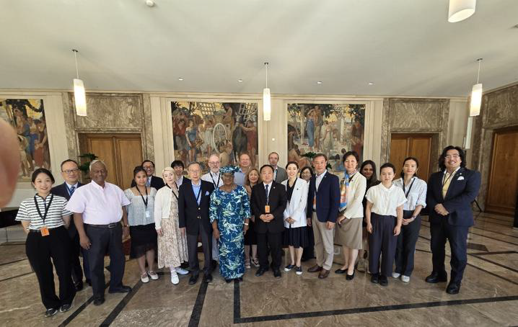
Dr. Okonjo-Iweala acknowledged at the outset that the global economy was experiencing profound disruption and uncertainty. These conditions were particularly difficult for businesses, which required a predictable environment in which to make investment and production decisions, and for younger generations confronting an increasingly unclear economic and political future. Multilateralism was under sustained attack, contributing to a wider atmosphere of pessimism.
She nevertheless argued that criticism of multilateralism should not simply be rejected. International institutions needed to ask why the present backlash had emerged and to distinguish among the effects of geopolitical rivalry, shortcomings in domestic policymaking, and weaknesses within multilateral institutions themselves. Unless institutions engaged in serious self-examination, they would not be able to respond effectively to the dissatisfaction directed toward them.
Dr. Okonjo-Iweala emphasized that international cooperation remained indispensable because many contemporary problems could not be solved by individual countries. Climate change, water scarcity, pandemics, disease, and other challenges involving the global commons required collective action. The need for multilateralism therefore had not disappeared. Rather, the question was what form it should take and how existing institutions should change. Institutions needed to identify what should be preserved, what was no longer functioning, and where new arrangements were required.
Speaking specifically about the WTO, she recalled that the Marrakesh Agreement placed improvements in living standards, job creation, and sustainable development at the center of the Organization’s purposes. Trade governance was therefore not an end in itself; it was intended ultimately to improve people’s lives. A substantial part of the WTO system continued to function well. Reform should therefore not entail abandoning the multilateral trading system but updating those parts that were no longer capable of responding to contemporary economic realities. Dr. Okonjo-Iweala summarized this point through a light-hearted comparison. Although she was proud to be a grandmother, the world was no longer looking for “your grandmother’s multilateralism.” It required a modified form of multilateralism appropriate to twenty-first-century conditions.
The first major reform challenge concerned the WTO’s decision-making procedures. The WTO formally operates according to consensus, but in practice consensus is frequently treated as unanimity. Every member therefore possesses an effective veto. This arrangement has an important democratic quality. The smallest WTO member formally holds the same decision-making power as the largest economy. At the same time, it has made rapid decisions extremely difficult and enabled a single member to block an initiative supported by virtually the entire membership.
In an era of artificial intelligence, digital transformation, and rapidly changing technologies, the WTO cannot afford to take years to respond to every new development. Dr. Okonjo-Iweala therefore called for serious consideration of how consensus might be preserved without allowing the decision-making system to become immobilized.
Dr. Okonjo-Iweala offered the WTO Agreement on Fisheries Subsidies as an example of both the potential and the difficulties of consensus-based decision-making. Negotiations had continued for approximately 22 years, even though the objective (i.e., curbing subsidies associated with illegal, unreported, and unregulated fishing) was urgent. She recalled asking whether members intended to reach an agreement while fish stocks still existed or only after all the fish had disappeared. Sustained political effort eventually produced an agreement through consensus, and she stated that 121 countries were then engaged in its ratification.
The broader difficulty is that members sometimes used the WTO consensus process to pursue bilateral disputes unrelated to the substance of the multilateral negotiation. A member might block an agreement not because it opposed the trade rule itself, but because it had a political or economic disagreement with another country.
Dr. Okonjo-Iweala illustrated this problem through the WTO moratorium on customs duties on electronic transmissions. The moratorium covers transactions such as digitally delivered music, films, financial services, consulting, and other products or services transmitted electronically. The arrangement had been renewed periodically for almost three decades. When the United States proposed making it permanent, many developing countries expressed concern that the digital economy was evolving too quickly for them to accept a permanent commitment. Members consequently sought a compromise. According to Dr. Okonjo-Iweala, 165 of the WTO’s 166 members accepted a limited extension accompanied by further study, but one member withheld consensus. The decision could therefore not be completed despite overwhelming support. The example demonstrated the distinction between protecting a vital national interest and exercising a veto for reasons that might be unrelated to the agreement under consideration. It reinforced her argument that the WTO needed a more workable interpretation of consensus.
A second reform priority concerned the substance of WTO rules. Many existing agreements were developed when the multilateral trading system had far fewer participants and before the rise of contemporary economic powers, digital platforms, global production networks, and climate-related industrial policies. Rules on subsidies, state support, industrial competition, and the maintenance of a level playing field therefore require reconsideration. Dr. Okonjo-Iweala wondered whether existing subsidy disciplines were sufficiently flexible to accommodate investments in environmental technologies and climate-friendly production. For example, green subsidies had not been a central concern when many WTO rules were negotiated, yet they were now a major component of national industrial and environmental policy. The task is not simply to prohibit or permit subsidies in the abstract. Members need to distinguish among forms of public support, evaluate their effects on competition and development, and determine what policy space should be available for the green transition.
A third reform concern was whether the international trading system adequately served developing and least developed countries. Dr. Okonjo-Iweala drew attention to the continuing marginal position of Africa, whose share of world trade had remained below approximately 3% for decades. Least developed countries accounted for only around 1%. Part of the explanation lies in domestic economic and institutional weaknesses within those countries. Nevertheless, international rules, market structures, and the design of engagement with developing economies also contribute. Numerous preferential market-access programs have been established, including initiatives by developed economies and, more recently, China. Yet those programs have not produced the level of integration originally anticipated.
The WTO therefore needs to ask why trade preferences alone have not been sufficient and what additional regulatory, productive, financial, and institutional capabilities developing economies are required. Reform should focus not only on formal access to markets, but also on whether countries possess the capacity to produce, export, participate in digital trade, and move into higher-value economic activities.
Dr. Okonjo-Iweala cautioned against interpreting institutional shortcomings as evidence that the WTO has become irrelevant. She stated that approximately 72% of world trade continues to take place under WTO terms. This indicates that the core multilateral system remains operational. Most trade continues to depend upon agreed tariff schedules, nondiscrimination principles, technical rules, customs procedures, and other commitments established through the WTO. The danger is therefore not that the system has already disappeared, but that complacency and a failure to reform could allow it to erode gradually.
Dr. Okonjo-Iweala also addressed the WTO dispute-settlement system. The Appellate Body was rendered inoperative in 2019, but this does not mean that the entire dispute-settlement mechanism has ceased functioning. She stated that approximately 54 cases have proceeded since the Appellate Body became inactive. Panels and other parts of the system continue to operate.
The crisis has also encouraged members to reconsider the original purpose of dispute settlement. The system had not been designed on the assumption that every disagreement should proceed immediately to full litigation. Members were expected first to consult, negotiate, and attempt to resolve their differences.
As appellate review has become less readily available, members have increasingly returned to consultation and negotiated settlement. Participating countries had also established the Multi-Party Interim Appeal Arbitration Arrangement, providing an alternative form of appellate review while comprehensive reform remained unresolved. Dr. Okonjo-Iweala therefore characterized the WTO as adaptive rather than static. The WTO has not simply waited for the former system to be restored; its members have developed interim mechanisms and alternative practices.
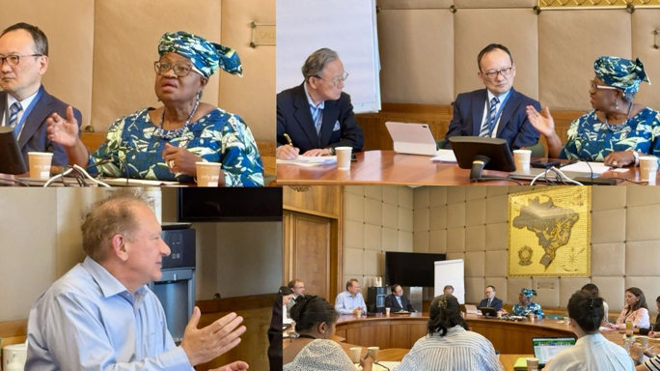
Although much of the discussion surrounding the WTO focused on crisis, Dr. Okonjo-Iweala urged the delegation not to overlook areas of economic dynamism. She identified three particularly significant developments:
- Services trade was expanding at approximately 5.3% annually
- Digitally delivered services were growing at approximately 6% annually
- Trade associated with environmental and green goods and services had reached approximately US$3 trillion
These developments create important opportunities for countries, businesses, and workers. They also raise a central institutional question: whether the WTO possesses rules capable of supporting these emerging forms of trade while ensuring that their benefits are widely shared.

Discussion
Professor Zhang Guihong asked how artificial intelligence was likely to affect international trade and what role the WTO should play in global AI governance.
Dr. Okonjo-Iweala explained that the WTO had anticipated the growing importance of AI and had established an AI and Frontier Technologies unit approximately three years earlier. The Organization had conducted research on the implications of AI for trade, including a study entitled Trading with Intelligence and subsequent work through the World Trade Report. WTO analysis projected that, if AI were adopted broadly, global trade could increase by approximately 40% by 2040. The principal mechanisms would be increased productivity and reductions in the cost of conducting international trade. The projected gains were not automatic. If developing countries lack the infrastructure, skills, finance, and institutional capacity required to adopt AI, technological change could deepen rather than reduce existing inequalities. She stated that broad AI adoption could also produce additional global GDP growth of approximately 13 to 15%. These benefits, however, depended upon access being distributed sufficiently widely.
The WTO was examining both the external implications of AI for members and its internal use within the Organization. Dr. Okonjo-Iweala also referred to her participation in the AI for Good initiative. While the WTO faces financial constraints that limit the speed of technological adoption, she argued that it remains actively engaged in the intellectual, policy, and institutional dimensions of AI.
Ms. Motoko Mizuno asked how the growing number of bilateral, regional, and free trade agreements affected the WTO’s role.
Dr. Okonjo-Iweala rejected the view that these agreements necessarily fragmented or marginalized the multilateral system. The continued conduct of approximately 72% of global trade under WTO terms demonstrates that the WTO remains the central framework. Regional and bilateral agreements generally build upon WTO principles. The WTO maintains dedicated capacity to examine such arrangements and assess their consistency with multilateral rules. Although not every provision of every agreement is necessarily compliant, the great majority operates within a broader WTO-based system. She therefore described the contemporary trade architecture as consisting of the WTO at its core, surrounded by concentric circles of bilateral and regional agreements that could complement the multilateral framework.
Dr. Okonjo-Iweala recalled that the architects of the multilateral trading system believed that economic interdependence could support peace and improve living standards. While those expectations had not been fulfilled equally everywhere, trade integration had contributed to lifting approximately 1.5 billion people out of poverty. China accounts for an important share of that achievement, but poverty reduction had also occurs in other developing economies. Advanced economies have benefited through employment, growth, investment, and access to global markets. The distribution of gains has nevertheless been uneven. Some workers, communities, and countries have not benefited sufficiently, contributing to the contemporary backlash against trade and globalization.
Dr. Okonjo-Iweala identified excessive economic dependence as one of the less healthy patterns to emerge from globalization. Many East Asian economies have become heavily dependent on demand from the United States. She referred to the concentration of Japanese investment in the United States and the European Union and suggested that Japan could expand its engagement with regions such as Latin America. Smaller East Asian economies, including Cambodia and Viet Nam, are similarly dependent on access to the U.S. market.
Dependence also existed on the supply side. Many countries rely heavily on China for rare-earth processing, critical minerals, chemicals, and industrial inputs. Global semiconductor production is highly concentrated in Chinese Taipei. Such concentration creates economic and national-security vulnerabilities. Dr. Okonjo-Iweala therefore advocated diversification across both sources of supply and export markets. Regional and free trade agreements can contribute to this diversification. Rather than undermining the WTO, well-designed agreements can distribute trade and investment more broadly while remaining anchored in multilateral principles.
Professor Vesselin Popovski returned to the question of consensus. He observed that the WTO was not the only institution affected by a single-member veto. He raised the example of the European Union, which had confronted comparable difficulties, including the blocking of decisions by Hungary, while ASEAN had also debated mechanisms for acting when one member prevented collective agreement. Variations of a “consensus-minus-one” approach might therefore offer relevant institutional lessons for the WTO. Professor Popovski acknowledged that reforming consensus procedures would be politically difficult and would require time, negotiation, and institutional experimentation. Nevertheless, the experience of other regional organizations suggested that alternatives could be developed without wholly abandoning the principle of consensus.
Dr. Okonjo-Iweala welcomed the observation as encouraging and suggested, with some humor, that the scholars might help persuade WTO members to consider such alternatives.
In closing, Professor Hasegawa thanked Dr. Okonjo-Iweala for her candid and forward-looking reflections. The exchange reinforced the central themes raised during the earlier WTO briefing. The multilateral trading system is under severe pressure from geopolitical rivalry, unilateral trade measures, economic insecurity, technological disruption, and dissatisfaction with the unequal distribution of gains. At the same time, the WTO continues to govern the majority of world trade, provide functioning dispute-settlement processes, support bilateral and regional agreements, and create a forum in which members could negotiate new rules.
Dr. Okonjo-Iweala’s principal message was that the current crisis should neither be denied nor treated as evidence that multilateralism had failed irreversibly. The appropriate response is critical reform: preserving the rules and institutions that continue to provide stability while changing the procedures, disciplines, and development approaches that no longer meet contemporary needs. Multilateralism can survive, but it cannot remain static.

Session 6: Office of the United Nations High Commissioner for Human Rights
The delegation visited Palais Wilson, headquarters of the Office of the United Nations High Commissioner for Human Rights, for a courtesy tour and subsequent discussion with Mr. Rory Mungoven, Chief of the Asia-Pacific Section in the Global Operations Division; Mr. Marco Zanin, Coordinator with the Global Alliance Initiative; and Ms. Gloria Nwabuogu of the Executive Office.
Ms. Nwabuogu introduced the speakers. Mr. Mungoven was responsible for supporting OHCHR’s work across the Asia-Pacific region from headquarters, while Mr. Zanin was working on the newly launched Global Alliance for Human Rights. Ms. Nwabuogu explained that her own work concerned diversity, inclusion, and the composition and organizational culture of the Office.
Mr. Mungoven welcomed the delegation to what he called the “home of human rights.” He recalled the previous Asian Scholars’ Dialogue visit in 2019 and observed that the international environment had changed substantially during the intervening years. While the human rights mandate remains constant, its application has had to evolve in response to new challenges. Artificial intelligence, digital technology, climate change, and environmental degradation were creating questions that could not have been fully anticipated when the contemporary human rights architecture was established. OHCHR therefore has to continue interpreting established principles in relation to changing technological, political, and social conditions.
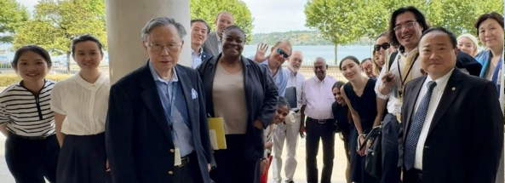
Mr. Mungoven explained that he supports OHCHR’s work in the Asia-Pacific region from Geneva, alongside regional offices in Bangkok and Suva. He emphasized the importance of the Office’s relationships with Japan and other Asian countries and expressed interest in developing stronger connections with scholars and universities in Japan, China, India, the Republic of Korea, and elsewhere in the region. He conveyed greetings from UN High Commissioner for Human Rights Volker Türk, who had recently visited Tokyo and was currently participating in discussions concerning AI governance and human rights at the AI Summit for Good. Mr. Mungoven presented academic institutions as an important constituency for OHCHR, particularly as the Office sought to strengthen its research and policy capacity on emerging issues.
Mr. Mungoven went on to identify the crisis facing multilateralism as one of the defining features of the current international environment. The multilateral order was under a degree of pressure not experienced during much of the preceding 80 years. At the same time, many Asia-Pacific states continue to regard multilateral institutions and international law as essential protections. For small and medium-sized countries, multilateral forums provide opportunities to convene, form coalitions, and protect their interests in an era of intensifying great-power competition.
The international legal order can serve as both a shield and a framework for the continuing development of countries in the region. Many Asia-Pacific states have moved toward higher levels of income and institutional capacity, and their continued economic and political progress remains connected to stable international systems governing human rights, trade, development, security, and cooperation. Mr. Mungoven referred to China, Japan, and India as major regional actors that continue to articulate support for multilateralism, although they approach institutional reform and global governance from different perspectives. He suggested that the Asia-Pacific region could become an especially important source of support for the survival and renewal of the international order.
A distinctive feature of the Asia-Pacific region is the absence of a comprehensive regional human rights architecture. Europe, Africa, and the Americas have developed regional charters, courts, commissions, and other institutions. Even where those systems face political and institutional limitations, they provide an initial regional forum for addressing human rights crises, conflicts, and institutional disputes. The Asia-Pacific region has no comparable region-wide framework. ASEAN has gradually developed certain human rights institutions and consensus-based arrangements, while the Pacific island states have begun exploring forms of regional cooperation. These mechanisms, however, do not encompass the entire Asia-Pacific region. The region’s breadth, political diversity, and geopolitical divisions make the construction of a single system exceptionally difficult. There is no common institutional forum encompassing Japan, China, India, Northeast Asia, South Asia, Southeast Asia, and the Pacific.
As a result, major regional situations, including those involving the Democratic People’s Republic of Korea and Myanmar, frequently move directly to the global level. Instead of first being addressed through a regional human rights institution, they are taken to the United Nations in Geneva or New York.
Mr. Mungoven contrasted the relative functionality of the Human Rights Council (HRC) with paralysis and polarization elsewhere in the UN system.
Despite political disagreements, the HRC has continued to adopt resolutions, establish investigative mechanisms, and respond to human-rights crises. Most HRC resolutions are still adopted by consensus. The HRC has created mechanisms addressing situations including Sudan and Myanmar and has remained a forum in which Member States can produce collective outcomes. The problem, paradoxically, is sometimes excessive productivity. The expanding number of resolutions, investigative bodies, reporting requirements, and mandates place substantial demands on limited OHCHR personnel and resources. The continued creation of mandates therefore needs to be accompanied by efforts to improve their effectiveness, coordination, and sustainability. Nevertheless, the HRC demonstrates that multilateral human-rights cooperation remains possible. Geneva continues to provide political and institutional space for agreements and mechanisms that might be difficult to establish elsewhere in the international system.
Mr. Mungoven explained that OHCHR performs several interconnected functions.
First, the High Commissioner holds an independent mandate from the General Assembly to engage governments and other stakeholders and to advance human rights globally.
Second, OHCHR serves as the secretariat supporting the wider UN human rights machinery. This includes the Human Rights Council, treaty bodies, the Universal Periodic Review, special rapporteurs, commissions of inquiry, and other independent mechanisms. This relationship sometimes generates misunderstanding. Treaty bodies, special rapporteurs, and investigative mechanisms exercise independent mandates, but OHCHR provides the administrative, technical, and research support needed for them to operate. Governments sometimes blame the OHCHR for conclusions reached independently by one of those mechanisms. At the same time, the OHCHR itself seeks constructive engagement with states, even where independent mechanisms publicly criticize them. Human rights work, therefore, involves both public accountability and quieter forms of cooperation, technical assistance, and capacity-building.
Mr. Mungoven cited the Democratic People’s Republic of Korea as an example. The country rejected recurring Human Rights Council resolutions as politicized, yet it has still engaged with OHCHR on certain substantive issues. Mr. Mungoven and Mr. Zanin hosted a delegation for discussions concerning the rights of persons with disabilities, for example, demonstrating that public scrutiny and practical cooperation did not have to be mutually exclusive.
A third important function of OHCHR is research. Mr. Mungoven described the Office as, in some respects, a human rights think tank. New issues often require foundational analysis before governments and international institutions can develop appropriate policies. OHCHR is therefore conducting work on the human rights implications of artificial intelligence and digital technologies, including how governments can facilitate innovation while protecting individuals and communities from discrimination, surveillance, exclusion, and other harms. OHCHR is similarly examining the human rights dimensions of climate change and considering how environmental and climate action can be designed through a rights-based framework. These research priorities create significant opportunities for cooperation with universities and scholarly networks. Mr. Mungoven encouraged the participating scholars to explore research partnerships between OHCHR and academic institutions across Asia.
Mr. Zanin introduced the Global Alliance for Human Rights, a new initiative launched by the High Commissioner in June 2026 following several months of institutional development. The initiative arose from the recognition that OHCHR cannot advance human rights alone. Numerous actors, including governments, universities, researchers, civil-society organizations, young people, athletes, public figures, and private institutions, are already contributing to human rights work but were not always connected to one another or to the UN human rights system. The Global Alliance seeks to bring those actors together, improve coordination, and connect global human rights principles with implementation at national and local levels. It is intended to build upon existing work rather than establish an entirely separate institutional structure. Youth and gender were identified as important priorities. The initiative also aims to encourage Member States to participate alongside non-governmental partners and to connect international advocacy with practical implementation.
A central component of the Global Alliance was the Research for Rights Network. Mr. Zanin observed that many scholars and academic networks are studying issues relevant to human rights without necessarily being connected across disciplines or regions. Some research has significant human rights implications even when the researchers themselves did not initially frame their work in those terms. The Research for Rights platform is intended to connect these scholars, identify common research challenges, and facilitate multidisciplinary collaboration with OHCHR. The platform is in an early stage of development but has been opened to applications from interested scholars and institutions. OHCHR has published examples of research challenges that academics could address, while also inviting participants to propose their own areas of work. The objective is to establish a more systematic connection between the High Commissioner’s mandate, the research needs of the Office, and expertise located within universities around the world.
Mr. Zanin highlighted AI, emerging technology, accessibility, and the rights of persons with disabilities as fields in which Asian expertise could make an important global contribution. Innovations being developed in Asia to improve access to education, employment, transportation, and public services could be shared across regions through the Global Alliance. The initiative is therefore intended not only to bring international standards into Asia, but also to transfer knowledge and practices developed in Asian countries to other parts of the world.
Ms. Nwabuogu then addressed diversity and inclusion within OHCHR and the wider UN Secretariat. She emphasized that the composition of the workforce affected both the legitimacy of the OHCHR and the quality of its work. Institutions created in a very different historical period needed personnel capable of understanding the contemporary world and responding to its changing regional, technological, and demographic realities. Diversity is therefore not simply an internal human resources matter. It shapes which experiences, perspectives, and forms of knowledge are present when international problems are analyzed and decisions are made.
One priority is gender parity. The principle that men and women should have equal opportunities to work within the United Nations has been present since the adoption of the UN Charter. Nevertheless, sustained action has been required to translate that formal principle into equitable representation at all levels of the Organization.
Geographical diversity poses a further challenge. Certain countries and regions remain substantially underrepresented within the UN workforce. Ms. Nwabuogu identified the Asia-Pacific as one of the regions that did not have representation proportionate to its population, expertise, or contribution to international affairs. OHCHR is working with UN human resources offices to improve outreach and participation through mechanisms including the Junior Professional Officer program, Young Professionals Program, and internships. The objective is both to attract more young Asian professionals and to identify structural barriers affecting their recruitment and progression.
Ms. Nwabuogu also highlighted disability inclusion and generational diversity. The average age within the Secretariat is approximately 47. While experience remains important, the Organization also needs staff familiar with artificial intelligence, data analysis, behavioral science, innovation, and other skills required in a rapidly changing policy environment. Inclusive management similarly requires attention to organizational culture, unconscious bias, and the capacity of senior personnel to lead diverse teams. Ms. Nwabuogu’s role includes helping the High Commissioner and Deputy High Commissioner implement UN frameworks concerning gender equality, disability inclusion, geographical representation, and workplace inclusion.

Discussion
Dr. Jamie Pring asked what an Asia-Pacific human rights system might look like, what existing institutions could provide its foundation, and which structures should be strengthened or reconsidered.
Mr. Mungoven explained that earlier aspirations to establish a single regional architecture had repeatedly encountered the extraordinary diversity and geopolitical divisions of the Asia-Pacific. Attention had then shifted toward subregional approaches. ASEAN has made gradual progress, and the Pacific island states are beginning to explore comparable arrangements. South Asian regional cooperation remains constrained, while strategic competition makes the creation of a Northeast Asian mechanism particularly difficult.
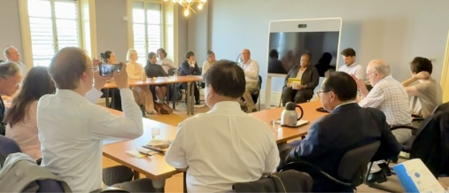
Mr. Mungoven referred to the work of Thai human rights scholar Vitit Muntarbhorn, who had advocated a building-block approach. Rather than attempting immediately to create a comprehensive regional court or commission, states can gradually develop human-rights components within existing regional bodies. Human rights can, for example, be mainstreamed into institutions concerned with trade, gender, migration, development, or security. A gender component might lead to a migration framework, which might in turn create broader human-rights practices. Over time, these subregional building blocks can potentially form the foundations of a more coherent regional system. The approach is incremental, but it is more politically realistic than attempting to impose a single institution across the entire region.
Professor Sudarshan Ramaswamy asked about the work of the international commission investigating violations affecting children and other civilians in Gaza, as well as the wider status and practical consequences of such investigations.
Mr. Mungoven described the conflict in Gaza as an existential crisis both for the people affected and for the credibility of the international order. OHCHR has maintained a human rights presence in the occupied Palestinian territory, including national personnel working in Gaza throughout the crisis. Their reporting has informed the High Commissioner’s public advocacy and analysis. OHCHR also coordinated protection work among UN agencies, including issues concerning children. Separately, the Human Rights Council had established an independent Commission of Inquiry to investigate violations in Israel and the occupied Palestinian territory. Mr. Mungoven noted that international judicial proceedings were also underway through the International Court of Justice and International Criminal Court concerning the conduct of parties to the conflict. These processes move slowly and operate in an intensely political environment. Nevertheless, he argued that the human-rights system has continued documenting violations, maintaining international attention, and supporting efforts toward accountability.
Professor Sheng Hongsheng asked about the distinction between lawful cross-border law-enforcement cooperation and unlawful transnational repression. He noted that governments could cooperate legitimately on matters such as criminal finance, extradition, and the recovery of illicit assets.
Mr. Mungoven agreed that international cooperation was essential for addressing terrorism, terrorist financing, narcotics, cybercrime, and other transnational threats. Such cooperation nevertheless had to be governed by human rights safeguards. States sometimes misused extradition, policing, or security arrangements to pursue individuals because of their political views, criticism of government, or human-rights activities rather than because of genuine criminal conduct. He referred to cases in which governments had sought the return of political opponents from neighboring states. Mechanisms established for legitimate law enforcement could therefore be abused to suppress dissent across borders. The central issue is not whether cross-border cooperation should occur, but whether procedures protect individuals against political persecution, torture, arbitrary detention, and other serious harms. Mr. Mungoven emphasized the principle of non-refoulement, which states that no individual should be transferred or returned to a country where there were substantial grounds for believing that they would face persecution or serious danger.
Professor Hasegawa asked how OHCHR understood diversity and inclusion amid political opposition to such policies, particularly from the Trump Administration in the United States.
Ms. Nwabuogu responded that “diversity and inclusion” was ultimately a contemporary label for principles that had long been embedded in international human rights law (e.g., equality and non-discrimination). These principles are reflected throughout international treaties concerning discrimination against women, racial discrimination, children’s rights, torture, disability, and other areas. The vast majority of UN Member States have ratified instruments containing obligations of equality and non-discrimination. Within the UN workforce, diversity and inclusion means ensuring equal opportunity, removing discriminatory barriers, and creating an environment in which personnel from different backgrounds can contribute effectively. Political controversy surrounding the terminology does not eliminate the underlying legal and ethical obligations. The credibility and effectiveness of a universal organization depend upon its ability to reflect the populations and regions it serves.
Ms. Nwabuogu reiterated that the Asia-Pacific region remains underrepresented in parts of the UN system. OHCHR is examining whether the problem persists because qualified candidates do not apply, fail to reach shortlists, encounter structural disadvantages, or lack adequate information about available career pathways. Representation is important not merely as a numerical objective. Bringing different intellectual traditions, regional experiences, and professional perspectives into the OHCHR can produce more creative and effective responses to global problems. A universal human rights institution cannot fully claim universality if major parts of the world are insufficiently represented among those conducting its work.
In closing, Mr. Mungoven encouraged the participants to remain in contact with the Office and to engage with the emerging Global Alliance. He noted that OHCHR has approximately 1,600 personnel, divided broadly between headquarters and field locations. The Office maintains around 15 field presences across Asia, including its regional offices. Important countries, including India, China, and Japan, currently do not host an OHCHR country presence. In his view, this limits opportunities for sustained networking, cooperation, and relationship-building. A broader regional presence could strengthen the OHCHR’s engagement with governments, academic institutions, civil society, and national human-rights communities.
Professor Hasegawa and the OHCHR representatives expressed interest in continuing discussions concerning academic cooperation, regional representation, and possible initiatives connected to the Global Alliance for Human Rights.

Session VII: Concluding Session with the Director-General of the United Nations Office at Geneva
The Asian Scholars’ Dialogue concluded with a meeting with Ms. Tatiana Valovaya, Director-General of the United Nations Office at Geneva, on the theme “United Nations at a Crossroads.” The session examined the meaning of UN reform, the future of multilateral governance, the institutional significance of Geneva, and the capacity of the United Nations to respond to rapidly changing global challenges.
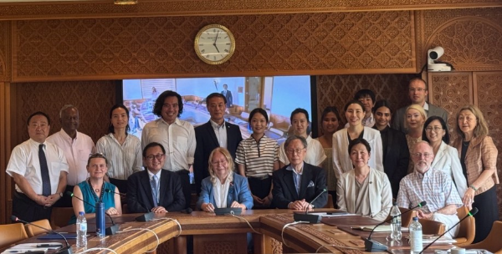
Director-General Valovaya began by asking how the United Nations could identify an appropriate role for itself in a world significantly different from that of its founding in 1945. Making the UN “fit for the twenty-first century,” she argued, could not be reduced to cutting budgets or reducing personnel.
She referred to the UN reform initiative under which substantial budget and staffing reductions have been proposed alongside a broader review of mandates, structures, and institutional effectiveness. Cost reduction was part of the exercise, but it was not its underlying purpose. The more important task was to determine which mandates remained necessary, which had become obsolete, where duplication could be eliminated, and how UN structures should reflect contemporary global needs.
Director-General Valovaya cautioned against interpreting reform as a return to the limited institutional responsibilities of 1945. More than eight decades have passed since the establishment of the United Nations, and the nature of international cooperation has changed profoundly. The UN has acquired new responsibilities because states face challenges that did not exist before, or had not been recognized as global governance questions, when the UN Charter was adopted. Reform, therefore, has to combine two processes:
- Reviewing outdated mandates, institutional duplication, and inefficient procedures
- Developing legitimate forms of multilateral governance for newly emerging global issues
Some mandates should have a clearer institutional life cycle and should be concluded when their purpose had been fulfilled. At the same time, simply eliminating activities without recognizing new governance needs would leave the United Nations less capable of serving its members. The objective is therefore not institutional contraction for its own sake. It is to make the UN more effective while preserving its capacity to respond to new conditions.
Director-General Valovaya identified artificial intelligence as a clear example of an emerging governance challenge.
The delegation’s visit coincided with the opening in Geneva of AI for Good Summit. She linked this process to the commitments made through the Pact for the Future and referred to the participation of a large number of Member States, senior government representatives, scientific experts, and other stakeholders. The United Nations had not originally been given an explicit mandate to govern artificial intelligence. Nevertheless, its wider responsibility to facilitate global cooperation requires it to identify governance gaps and present proposals to Member States. Where Member States endorse such initiatives, the UN has to develop the institutional capacity to move forward. AI demonstrates that UN reform cannot be confined to withdrawing from established fields. The UN also needs to enter areas in which technological change has created new forms of cross-border risk, interdependence, and public interest. This example illustrates a wider principle: the absence of an original or explicit mandate does not mean that the United Nations should remain passive when a genuinely global governance problem emerges. Its role is to convene, develop proposals, mobilize expertise, and enable governments collectively to determine the appropriate response.

Discussion
Dr. Xinyu Yuan observed that participants had repeatedly heard that the UN system needed to become more “agile.” She asked what agility meant in practical institutional terms, particularly for fields such as human rights and health.
Director-General Valovaya described agility as the capacity to be responsive, intelligent, adaptable, and capable of acting quickly. The central problem was that the world was changing far more rapidly than traditional multilateral decision-making procedures. Intergovernmental negotiations have to incorporate the positions of 193 Member States. Governments need time to consult nationally, negotiate internationally, examine possible outcomes, and approve decisions at the appropriate political level. These requirements protect state participation and legitimacy, but they also make the system inherently slow. In an era of social media, internet-based communication, rapidly developing technology, and fast-moving transnational crises, the United Nations can no longer assume that it has five years in which to negotiate every agreement. Institutional agility therefore requires both faster procedures and clearer advance authority. International organizations need to know what they can do when a crisis emerges rather than waiting for governments to negotiate every operational decision after the emergency has already begun.
Director-General Valovaya distinguished the UN system from supranational institutions such as the European Union. The European Commission exercises authority that Member States have formally delegated to it. In defined areas, it can take decisions without returning to every government for case-by-case authorization. The United Nations and its specialized agencies remain intergovernmental. Their secretariats may possess extensive technical expertise, but where action falls outside an existing mandate, they must obtain authorization through Member-State governing bodies.
The Covid-19 pandemic exposed the limitations of this model. Technical experts could identify necessary measures before the relevant organization had received full political authorization to act. Valuable time was lost while intergovernmental consultations proceeded.
Director-General Valovaya referred to the Pandemic Agreement as an effort to learn from this experience. The purpose of advance rules and agreed responsibilities is to provide relevant organizations with a clearer guide for action during a future emergency. With this, they will not need to reopen every institutional question while simultaneously attempting to control a rapidly developing crisis. Agility does not mean abandoning state authority. Rather, Member States can use agreements adopted in advance to establish how trusted professional institutions should respond when defined conditions arise. The challenge is to distinguish necessary democratic and diplomatic procedures from bureaucracy that exists largely for its own sake. Reform should preserve Member-State control while reducing avoidable delays and enabling institutions to act more quickly and effectively.
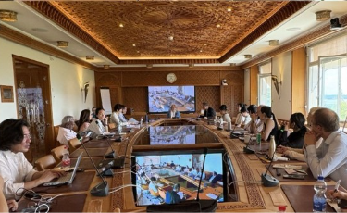
Professor Zhang Guihong referred to China’s Global Governance Initiative and its proposed principles and asked how major-power initiatives could contribute to the reform of international governance.
Director-General Valovaya emphasized that the effectiveness of any governance proposal depended significantly upon the conduct and interests of major powers. It was therefore important that large states, including China, continued to support the multilateral system and offered proposals intended to strengthen global governance rather than replace collective institutions with unilateral arrangements. Her response reflected a recurring theme of the session: major powers possess disproportionate capacity to sustain or weaken multilateral institutions. Their leadership is valuable when it reinforces common rules and inclusive structures but potentially destabilizing when it seeks exclusive control.
Professor Sho Akahoshi asked what distinguished Geneva from other international centers, particularly New York, and what advantages arose from locating major international organizations there.
Director-General Valovaya described Geneva as the world’s oldest and most developed multilateral ecosystem. Its institutional history began with the League of Nations, whose physical and organizational legacy was later inherited by the United Nations. The Palais des Nations had been constructed for the League, while the building now occupied by the World Trade Organization had originally been built for the International Labor Organization. Institutions such as the Graduate Institute had also developed alongside the early multilateral system. Geneva therefore inherited not only buildings but also an accumulated culture of diplomacy, international administration, research, and cooperation. New institutions had been added to this existing foundation over time.
Director-General Valovaya distinguished Geneva from New York in functional terms. UN Headquarters in New York is centered principally on the UN Secretariat, General Assembly, and Security Council. Its institutional life is therefore closely connected to high-level political deliberation, international peace, and security. Geneva, in contrast, hosts a much more diverse concentration of specialized organizations. Approximately 40 international organizations, together with UN funds, programs, agencies, and offices, addressed issues including: peace and disarmament, sustainable development, international trade, labor, human rights, public health, humanitarian action, and science and technology. The city consequently brings together the principal pillars of the United Nations: peace, development, and human rights.
Geneva’s significance also arose from the diversity of actors present there. Director-General Valovaya noted that approximately 187 permanent missions maintain a presence in the city. This gives Geneva nearly universal diplomatic representation and allows governments to respond rapidly when negotiations or crises require cross-sector engagement.
Civil society is also deeply integrated into the Geneva ecosystem. Approximately 5,000 representatives of accredited non-governmental organizations receive annual badges providing continuing access to the Palais des Nations and to relevant proceedings, including meetings of the Human Rights Council. Universities and research institutions supply expertise and maintain sustained relationships with international organizations. Geneva also supports engagement with young people and the private sector, including through the presence of organizations such as the World Economic Forum.
The result is a dense ecosystem in which diplomats, international officials, researchers, civil-society representatives, technical experts, and businesses can interact. This infrastructure makes Geneva well suited not only to routine institutional work but also to major global events, including emerging discussions on artificial intelligence. Director-General Valovaya observed that Geneva has hosted more international conferences than New York in recent years. Its comparative advantage is precisely its breadth. It is not limited to one policy field or one category of international actor.
Ms. Motoko Mizuno observed that almost every organization visited by the delegation had described the United Nations as being in crisis and in need of reform. Drawing upon her experience in the space sector, she referred to the difficulty of updating international space law through consensus. Earlier negotiations had produced foundational treaties, but the unanimity requirement had made subsequent amendment extremely difficult. States had often been able to agree only on non-binding General Assembly resolutions and soft-law instruments. She asked whether majority voting or alternative decision-making procedures could make the United Nations more responsive.
Director-General Valovaya distinguished between two dimensions of the contemporary UN crisis. The first was a financial crisis. In one sense, she described this as the simpler problem: were all Member States to pay their assessed contributions fully and on time, much of the immediate liquidity crisis would disappear. The deeper vulnerability was the UN’s dependence on a small number of major contributors. China and the United States together accounted for a very substantial share of the regular budget. When one large contributor delayed or withheld payment, contributions from all other countries could not fully compensate for the resulting gap. Such dependence was structurally unsustainable and left the UN vulnerable to the domestic politics and bilateral decisions of a small number of governments.
The second dimension concerned the future design of the UN. The UN had been created on the basis of consensus and the veto rights of permanent members of the Security Council. These arrangements were understandable within the political realities of 1945. The contemporary world, however, has changed too quickly for every decision to depend upon prolonged efforts to secure complete consensus. The question is whether alternative models can be introduced without destroying the principle of sovereign equality that made universal participation possible.
Director-General Valovaya referred to supranational systems such as the European Union and the Eurasian Economic Union, in which governments had consciously delegated authority and accepted defined forms of majority voting. These models were coherent within regional integration systems. She did not, however, believe that they could be applied wholesale to the United Nations, particularly in politically sensitive fields.
A defining attraction of the UN was that every state knew its voice counted and that decisions could not simply be imposed upon it. Even an isolated country could present a position it considered essential to its national interests. In a period of geopolitical tension, eliminating this protection could drive governments away from multilateral institutions rather than make those institutions more effective. The challenge is therefore to improve decision-making without transforming the UN into a system in which a majority could routinely override the fundamental concerns of individual states.
Director-General Valovaya proposed two more incremental approaches.
First, permanent members of the Security Council could be encouraged to exercise restraint. Formal veto rights might remain, but governments could commit not to use them except where genuinely vital national interests were involved. Such an arrangement would depend upon political responsibility rather than formal Charter amendment, but it could reduce paralysis if permanent members accepted that not every disagreement justified blocking collective action.
Second, Member States could delegate greater authority to existing professional institutions. Organizations such as the World Health Organization and International Labor Organization possessed specialized expertise and institutional leadership chosen by the membership. Where decisions were technical rather than fundamentally political, governments could authorize those institutions to act within broader parameters. Professional officials could often reach decisions more quickly and on the basis of stronger evidence than politically divided intergovernmental bodies.
Director-General Valovaya stressed that describing states as politically motivated was not a criticism; it was a recognition of their institutional role. Governments, of course, represent national interests. Technical organizations, by contrast, are designed to apply professional expertise. Effective reform might therefore depend upon determining which decisions genuinely required political negotiation and which could safely be entrusted to specialized institutions.
Professor Sheng Hongsheng asked how the United Nations could avoid being displaced by alternative international bodies created by a major power. He expressed concern that ad hoc boards, coalitions, or commissions could be established outside the UN to manage international conflicts and thereby weaken the Organization’s central role.
Director-General Valovaya responded that powerful states sometimes assumed they should lead and benefit disproportionately from multilateral institutions because of their size and strength. The answer demonstrated that only a balanced and inclusive system could retain legitimacy and function over time. A system directed according to the will of one country would eventually lose the participation and confidence of others. Even powerful states could find themselves isolated on particular issues. Universal multilateral institutions remained valuable because they allowed all governments, including governments that strongly disagreed with one another, to sit at the same table, explain their positions, confront criticism, and search for solutions. The alternative was not necessarily more effective governance. It could instead produce fragmented political blocs without a common forum through which disputes could be managed.
Director-General Valovaya invoked the experience of the League of Nations. During the 1930s, countries withdrew or were expelled as the institution became progressively less universal. Exclusion did not improve international conduct or preserve peace. Instead, it created an environment in which governments no longer shared an effective common forum. The lesson is that criticism of a Member State’s behavior should not automatically lead to the destruction of the institutional space in which that state could be confronted and engaged.
The United Nations has to remain an organization of and for all its Member States. Governments might criticize one another, be criticized themselves, or become isolated on particular questions. Nevertheless, they need a place where each retains a voice and where communication remains possible.
Professor Hasegawa thanked Director-General Valovaya for making herself available to the delegation and for supporting the broader program of meetings with UN bodies and other international organizations.
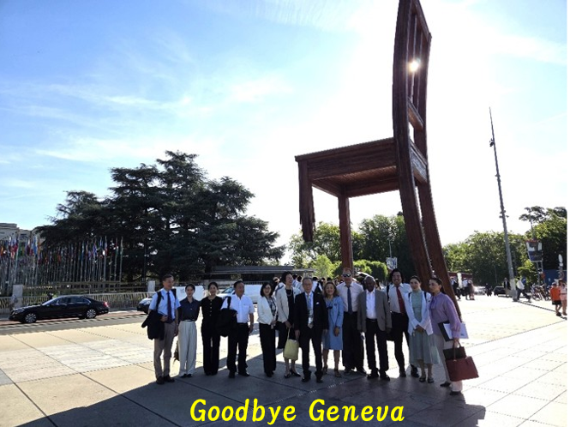

This recollection echoes a notable 2014 NPR interview with Former U.S. Secretary of State, Madeleine Albright, on the forthcoming 70th Anniversary of the United Nations, in which she said of the UN, that “if it didn't exist, we would invent it.” https://www.npr.org/2014/12/28/373587972/albright-on-the-u-n-if-it-didnt-exist-we-would-invent-it
For more information of the UN80 Initiative, please see: https://www.un.org/un80-initiative/en/all-un80-related-resources-and-documents
For information on revisions to the selection process of the UN Secretary General, please see: https://docs.un.org/en/A/RES/69/321
For information on the escalating situation in Haiti, please see: https://www.csis.org/analysis/united-states-votes-establish-haiti-gang-suppression-force-now-what and, for a update on the UN response, https://www.npr.org/2026/06/17/g-s1-128536/un-chief-visits-haiti and https://youtu.be/7q7rz7K0J-M?si=PQpr6mY9p_pbvgeL.
In an interview with former JIU Inspector, Mr. Wolfgang Münch, he recounts how it was suggested in 1995 that the JIU should withdraw due to cost savings. This proposal was ultimately rejected by Member States. https://www.unjiu.org/news/interview-former-inspector-wolfgang-m%C3%BCnch
For more information, please see: https://www.un.org/en/about-us/un-charter/chapter-18
For more information about the situation in Venezuela, please see: https://www.consilium.europa.eu/en/policies/venezuela/
For more information about the situation in Syria, please see: https://news.un.org/en/story/2025/12/1166629
For a perspective on the “proxy war” dynamic in Syria, please see: https://theconversation.com/how-to-understand-syrias-proxy-war-and-whos-fighting-for-whom-65685
For more on the impact of the dissolution of USAID on humanitarian aid, please see: https://www.oxfamamerica.org/explore/issues/making-foreign-aid-work/what-do-trumps-proposed-foreign-aid-cuts-mean/
For more information about the “humanitarian rest,” please see: https://www.unocha.org/news/humanitarian-reset-10-march-2025
For more information about the Grand Bargain, please see: https://www.unocha.org/publications/report/world/grand-bargain-shared-commitment-better-serve-people-need
For more information about the Brahimi Report, please see: https://peacekeeping.un.org/sites/default/files/a_55_305_e_brahimi_report.pdf
For more information on UNGA Resolution 46/182, please see: https://docs.un.org/en/a/res/46/182
Study Group 2 on Inter-service sharing and compatibility​ was disbanded. See more: https://www.itu.int/en/ITU-R/study-groups/Pages/Disbanded-Groups.aspx
For more information on WTO principles, please see: https://www.wto.org/english/thewto_e/whatis_e/tif_e/fact2_e.htm
For more information on the Joint Statement Initiative on Electronic Commerce, please see: https://wtoplurilaterals.info/plural_initiative/e-commerce/
For more information on the Investment Facilitation for Development Agreement, please see: https://www.wto.org/english/tratop_e/invfac_public_e/invfac_intro_e.htm
For more information on Singapore’s perspective on the role of more responsible consensus at the WTO and the impact such measures have within multilateralism, please see: https://www.istana.gov.sg/newsroom/an-era-of-possibility-renewing-economic-order-and-shared-purpose-by-president-tharman-shanmugaratnam/
For more information about Article 25 of the Dispute Settlement Understanding, please see: https://www.wto.org/english/res_e/publications_e/ai17_e/dsu_art25_jur.pdf
For more information about the Multi-Party Interim Appeal Arbitration Arrangement, please see: https://wtoplurilaterals.info/plural_initiative/the-mpia/
For more information on the Uruguay Round, please see: https://www.wto.org/english/thewto_e/whatis_e/tif_e/fact5_e.htm
For more information on the Marrakesh Agreement, please see: https://www.wto.org/english/docs_e/legal_e/marag_e.htm
For more information on the World Intellectual Property Organization, please see: https://www.wipo.int/portal/en/index.html
For more information on the Agreement on Trade-Related Aspects of Intellectual Property Rights, please see: https://www.wto.org/english/tratop_e/trips_e/trips_e.htm
For more information about the ePing platform, please see: https://www.epingalert.org/
For more information on the WTO Appellate Body being rendered inoperative, please see: https://www.wto.org/english/tratop_e/dispu_e/sunata_19_e.htm
For more information on the Multi-Party Interim Appeal Arbitration Arrangement, please see: https://www.wto.org/english/tratop_e/dispu_e/altds_e.htm
To view the report, please see: https://www.wto.org/english/res_e/publications_e/trading_with_intelligence_e.htm
To see the repository of annual reports, please see: https://www.wto.org/english/res_e/reser_e/wtr_e.htm
For more information about the Global Alliance for Human Rights, please see: https://globalalliance.un.org/
To learn more about the Research for Rights Network, please see: https://globalalliance.un.org/research
For more information on Vitit Muntarbhorn, please see: https://www.pilnet.org/profiles/vitit-muntarbhorn/ and https://www.ohchr.org/en/special-procedures/ie-sexual-orientation-and-gender-identity/vitit-muntarbhorn
To learn more about the Pandemic Agreement, please see: https://news.un.org/en/story/2025/04/1162301
To learn more about China’s Global Governance Initiative, please see: https://www.unachina.org/en/article/1151

